Deep Learning Techniques for Forecasting Electrical Loads

by

Tolulope Oluwaseun Olugbenga

BSc in Computer Science Engineering, University of Debrecen, 2018

A Thesis Submitted in Partial Fulfillment   
of the Requirements for the Degree of

Master of Science in Engineering

in the Graduate Academic Unit of Electrical and Computer Engineering

Supervisors: Dr. Dawn MacIsaac, Ph.D., Electrical and Computer Engineering

Dr. Julian Cardenas, Ph.D., Electrical and Computer Engineering

Examining Board: Dr. Erik Scheme, Ph.D., Electrical and Computer Engineering

Dr. Julian Meng, Ph.D., Electrical and Computer Engineering

Dr. Suprio Ray, Ph.D., Computer Science

This thesis is accepted by the

Dean of Graduate Studies

THE UNIVERSITY OF NEW BRUNSWICK

December 2021

© Tolulope Oluwaseun Olugbenga, 2021

ABSTRACT

Load forecasting is critical for power system operators to maintain a safe and efficient network. By ensuring that consumers receive adequate energy, load forecasting helps maintain the supply-demand balance. Load forecasting can benefit companies such as load aggregators, power marketers, and independent system operators. Excess production and expense are a result of over-forecasting. An unexpectedly high load results in an electricity deficit. Both scenarios result in inefficient generation scheduling and technical difficulties for the operator. Developing a forecasting model for a particular power network is not straightforward. In load forecasting, statistical and machine-learning techniques have been used. Deep learning techniques have recently gained popularity due to their improved ability to interpret complex data relationships. The purpose of this study was to compare deep learning forecasting techniques to some conventional forecasting techniques used by utilities in order to determine whether deep learning can better meet their needs.

DEDICATION

This thesis is dedicated to my future self; I want him to look back and realize that his anguish, struggle, and late nights were not in vain. I adore you, and I am excited to meet the man you will become.

# ACKNOWLEDGEMENTS

This is, without a doubt, one of the most challenging journeys I have ever undertaken. It has shown me how much I can grow and accomplish when I believe in myself and put in the effort. It was an eye-opening experience, and I am grateful that I did not give up and instead persevered in my efforts to cross the finish line. When I first arrived at UNB and saw what my colleagues in the lab were working on, I honestly wondered what I had gotten myself into. After hearing from other students about how difficult it is to complete a thesis master's degree, I began to doubt my abilities and became concerned that I would not complete it.

I want to express my gratitude to my supervisors, Dr. Dawn MacIsaac and Dr. Julian Cardenas; I would not have completed this program without them. I appreciate your patience and encouraging words, which reminded me that anything is possible if I keep going. I would also like to express my gratitude to my family for always being there and motivating me to complete this program.

To be completely candid, the individual who entered the lab in December 2018 would not have been able to complete this degree. To complete, I needed to improve on both a personal and intellectual level. I want to applaud myself for not throwing in the towel and giving up; I want to commend myself for persevering through difficult times and even when the going became tougher. In a nutshell, this has been an educational experience and a game of physical and cognitive development. I would do it all over again if I had to because I would not be the man I am today without it. As a result, I would like to convey my appreciation to my supervisors and the University of New Brunswick for providing me with this opportunity to learn and develop as a person.

Table of Contents

ABSTRACT ii

DEDICATION iii

ACKNOWLEDGEMENTS iv

Table of Contents v

List of Tables ix

List of Figures x

List of Abbreviations xiv

1 Introduction 1

1.1 Objectives 3

2 Overview of Load Forecasting 5

2.1 Factors That Affect the Load Demand 5

2.2 Load Forecasting Horizons 6

2.3 The Benchmark Forecasters 7

2.3.1 The Seasonal Naïve Forecaster (SNF) 8

2.3.2 The Multiple Linear Regression Forecaster (MLR) 9

2.3.3 The Auto-Regressive Integrated Moving Average Forecaster (ARIMA) 10

2.3.4 Artificial Neural Network Short Term Load Forecaster – Generation Three (ANNSTLF-G3) 12

2.4 Deep Learning Techniques 16

2.4.1 Recurrent Neural Networks and the Long Short Term Memory Forecaster 17

2.4.2 The Convolutional Neural Network Forecaster (CNN) 20

2.4.3 A Literature Review on Deep Learning 23

2.5 The Myth of Finding the One Size Fits All Technique 24

2.6 Peak Load 24

2.7 Performance Metrics 26

3 Investigation 28

3.1 Preparation of the Datasets 28

3.2 Implementation Specifications for Benchmark Forecasters 30

3.2.1 The Seasonal Naïve Forecaster (SNF) 31

3.2.2 The Multiple Linear Regression Forecaster (MLR) 31

3.2.3 The Seasonal Auto-Regressive Integrated Moving Averages with Exogenous Regressors Forecaster (SARIMAX) 32

3.2.4 The Artificial Neural Network Short Term Load Forecaster (ANNSTLF-G3) 33

3.3 Implementation Specifications for the Deep Learning Forecasters 35

3.3.1 The Long Short Term Memory Forecaster (LSTM) 35

3.3.2 The Convolutional Neural Network Forecaster (CNN) 35

3.4 Method Analysis 36

3.5 The Performance of Forecasters on the Toronto Dataset 37

3.5.1 Discussion of the Toronto Dataset's Overall Performance 38

3.6 The Performance of Forecasters on the Ottawa Dataset 38

3.6.1 Discussion of the Ottawa Dataset's Overall Performance 39

3.7 The Performance of Forecasters on the Saint John Dataset 40

3.7.1 Discussion of the Saint John Dataset's Overall Performance 41

3.8 Conclusion 41

4 Comprehensive Evaluation of Our Forecasters' Performance 43

4.1 The Toronto Dataset 43

4.1.1 The Hourly Performance 44

4.1.2 The Daily Performance 45

4.1.4 Performance During the Seasons 48

4.1.5 Comprehensive Analysis Discussion 49

4.2 The Ottawa Dataset 50

4.2.1 The Hourly Performance 50

4.2.2 The Daily Performance 52

4.2.3 The Monthly Performance 53

4.2.4 Performance During the Seasons 55

4.2.5 Comprehensive Analysis Discussion 56

4.3 The Saint John Dataset 57

4.3.1 The Hourly Performance 58

4.3.2 The Daily Performance 59

4.3.3 The Monthly Performance 60

4.3.4 Performance During the Seasons 63

4.3.5 Comprehensive Analysis Discussion 63

5 Conclusion 66

5.1 Summary 66

5.2 Contributions 67

5.3 Future Work 67

Bibliography 69

Appendix A 90

1 Determining the SARIMAX Model's Optimal Parameters 90

1.1 Statistical Analysis of the Toronto Dataset 91

1.2 Statistical Analysis of the Ottawa Dataset 94

1.3 Statistical Analysis of the Saint John Dataset 97

Appendix B 101

1 Metrics for Overall Accuracy 101

1.1 The Toronto Dataset's Overall Performance Metrics 101

1.2 The Ottawa Dataset's Overall Performance Metrics 101

1.3 The Saint John Dataset's Overall Performance Metrics 101

2 Metrics for Peak Detection Accuracy 102

3 Other Forecasters' Box Plots of the Error Distribution 103

3.1 The Toronto Dataset 103

3.2 The Ottawa Dataset 108

3.3 The Saint John Dataset 112

Curriculum Vitae

List of Tables

Table 1 - Formulas for Several Frequently Used Performance Metrics 26

Table 2 - The MLR Forecaster's Independent Variables 32

Table 3 - The SARIMAX hyperparameters that were used across all datasets 32

Table 4 - Overall MAPE and RMSE for Each Forecaster – Toronto Dataset 37

Table 5 - Matrix Analysis of Peak Values and Time Difference – Toronto Dataset 37

Table 6 - Overall MAPE and RMSE for Each Forecaster – Ottawa Dataset 38

Table 7 - Matrix Analysis of Peak Values and Time Difference – Ottawa Dataset 39

Table 8 - Overall MAPE and RMSE for Each Forecaster – Saint John Dataset 40

Table 9 - Matrix Analysis of Peak Values and Time Difference – Saint John Dataset 40

Table 10 - Seasonal MAPE and RMSE for the Toronto Dataset 48

Table 11 - Seasonal MAPE and RMSE for the Ottawa Dataset 56

Table 12 - Seasonal MAPE and RMSE for the Saint John Dataset 63

Table 13 – The Overall Performance Metrics – Toronto Dataset 101

Table 14 - The Overall Performance Metrics – Ottawa Dataset 101

Table 15 - The Overall Performance Metrics – Saint John Dataset 101

List of Figures

Figure 1 - The Block Diagram of the Third Generation ANNSTLF [38] 13

Figure 2 - The Structure of a Simple Feed-forward ANN 14

Figure 3 - Unrolled Recurrent Neural Network (RNN) [133] 18

Figure 4 - The Block of Long-Term Short-Term Memory [134] 19

Figure 5 - An Illustration of a Typical CNN Network's Workflow [149] 21

Figure 6 – The Activation Function for Rectified Linear Units [150], and Examples of Max and Average Pooling [151]. 22

Figure 7 – Peak Load vs Base Load [165] 25

Figure 8 – 2019 Average Daily Demand for Loads Across All Datasets 29

Figure 9 – The Structure of the BLF and CLF Network 34

Figure 10 - Actual and Forecasted Load Demand for July 17th - 21st, and the Overall Error Distribution for All Forecasters - Toronto Dataset 38

Figure 11 - Actual and Forecasted Load Demand for July 17th - 21st, and Overall Error Distribution for All Forecasters - Ottawa Dataset 39

Figure 12 - Actual and Forecasted Load Demand for December 17th - 21st, and Overall Error Distribution for All Forecasters - Saint John Dataset 40

Figure 13 - Hourly MAPE and Hourly Error Distributions for CNN, LSTM, and ANN Forecasters – Toronto Dataset 44

Figure 14 – Daily MAPE and Daily Error Distributions for CNN, LSTM, and ANN Forecasters – Toronto Dataset 46

Figure 15 - Monthly MAPE and Monthly Error Distributions for CNN, LSTM, and ANN Forecasters – Toronto Dataset 47

Figure 16 - Scatter Plot of Load Demand versus Temperature – Toronto Dataset 49

Figure 17 - Hourly MAPE and Hourly Error Distributions for CNN, LSTM, and ANN Forecasters – Ottawa Dataset 51

Figure 18 - Daily MAPE and Daily Error Distributions for CNN, LSTM, and ANN Forecasters – Ottawa Dataset 53

Figure 19 - Monthly MAPE and Monthly Error Distributions for CNN, LSTM, and ANN Forecasters – Ottawa Dataset 54

Figure 20 - Scatter Plot of Load Demand versus Temperature – Ottawa Dataset 56

Figure 21 - Hourly MAPE and Hourly Error Distributions for CNN, LSTM, and ANN Forecasters – Saint John Dataset 58

Figure 22 - Daily MAPE and Daily Error Distributions for CNN, LSTM, and ANN Forecasters – Saint John Dataset 60

Figure 23 - Monthly MAPE for Each Forecaster – Saint John Dataset 61

Figure 24 - Monthly Error Distribution for CNN, LSTM, ANN, and SARIMAX Forecasters – Saint John Dataset 62

Figure 25 - Scatter Plot of Load Demand versus Temperature – Saint John Dataset 64

Figure 26 – Excerpt from the Toronto Dataset 91

Figure 27 – Plot of the Initial Auto Correlation – Toronto Dataset 92

Figure 28 – ACF Plot Following Seasonal Differencing – Toronto Dataset 92

Figure 29 – ACF Plot After Seasonal and Non-Seasonal Differencing – Toronto Dataset 93

Figure 30 - PACF Plot After Seasonal and Non-Seasonal Differencing – Toronto Dataset 93

Figure 31 - Excerpt from the Ottawa Dataset 94

Figure 32 - Plot of the Initial Auto Correlation – Ottawa Dataset 95

Figure 33 - ACF Plot Following Seasonal Differencing – Ottawa Dataset 96

Figure 34 - ACF Plot After Seasonal and Non-Seasonal Differencing – Ottawa Dataset 96

Figure 35 - PACF Plot After Seasonal and Non-Seasonal Differencing – Ottawa Dataset 97

Figure 36 - Excerpt from the Saint John Dataset 98

Figure 37 - Plot of the Initial Auto Correlation – Saint John Dataset 99

Figure 38 - ACF Plot Following Seasonal Differencing – Saint John Dataset 99

Figure 39 - ACF Plot After Seasonal and Non-Seasonal Differencing – Saint John Dataset 100

Figure 40 - PACF Plot After Seasonal and Non-Seasonal Differencing – Saint John Dataset 100

Figure 41 - Load Demand on March 11, 2019, and CNN Forecast – Toronto Dataset 102

Figure 42 - Hourly Error Distribution for the MLR Forecaster – Toronto Dataset 103

Figure 43 - Hourly Error Distribution for the SARIMAX Forecaster – Toronto Dataset 104

Figure 44 - Hourly Error Distribution for the SNF Forecaster – Toronto Dataset 104

Figure 45 - Daily Error Distribution for the MLR Forecaster – Toronto Dataset 105

Figure 46 - Daily Error Distribution for the SARIMAX Forecaster – Toronto Dataset 105

Figure 47 - Daily Error Distribution for the SNF Forecaster – Toronto Dataset 106

Figure 48 - Monthly Error Distribution for MLR Forecaster– Toronto Dataset 106

Figure 49 - Monthly Error Distribution for SARIMAX Forecaster– Toronto Dataset 107

Figure 50 - Monthly Error Distribution for SNF Forecaster– Toronto Dataset 107

Figure 51 - Hourly Error Distribution for the MLR Forecaster – Ottawa Dataset 108

Figure 52 - Hourly Error Distribution for the SARIMAX Forecaster – Ottawa Dataset 108

Figure 53 - Hourly Error Distribution for the SNF Forecaster – Ottawa Dataset 109

Figure 54 - Daily Error Distribution for the MLR Forecaster – Ottawa Dataset 109

Figure 55 - Daily Error Distribution for the SARIMAX Forecaster – Ottawa Dataset 110

Figure 56 - Daily Error Distribution for the SNF Forecaster – Ottawa Dataset 110

Figure 57 - Monthly Error Distribution for MLR Forecaster – Ottawa Dataset 111

Figure 58 - Monthly Error Distribution for SARIMAX Forecaster – Ottawa Dataset 111

Figure 59 - Monthly Error Distribution for SNF Forecaster – Ottawa Dataset 112

Figure 60 - Hourly Error Distribution for the MLR Forecaster – Saint John Dataset 112

Figure 61 - Hourly Error Distribution for the SARIMAX Forecaster – Saint John Dataset 113

Figure 62 - Hourly Error Distribution for the SNF Forecaster – Saint John Dataset 113

Figure 63 - Daily Error Distribution for the MLR Forecaster – Saint John Dataset 114

Figure 64 - Daily Error Distribution for the SARIMAX Forecaster – Saint John Dataset 114

Figure 65 - Daily Error Distribution for the SNF Forecaster – Saint John Dataset 115

Figure 66 - Monthly Error Distribution for MLR Forecaster – Saint John Dataset 115

Figure 67 - Monthly Error Distribution for SNF Forecaster – Saint John Dataset 116

List of Abbreviations

ANN – Artificial Neural Networks

ANNSTLF – Artificial Neural Networks Short Term Load Forecaster

ARIMA – Auto-Regressive Integrated Moving Average

ACF – Auto Correlation Function

BLF – Base Load Forecaster

CLF – Change in Load Forecaster

CNN – Convolutional Neural Networks

DL – Deep Learning

GRU – Gated Neural Networks

ICDAR - International Conference on Document Analysis and Recognition

ILSVRC - ImageNet Large Scale Visual Recognition Challenge

ISBI - International Symposium on Biomedical Imaging

LSTM – Long Short-Term Memory networks

LTLF – Long Term Load Forecasting

MAE – Mean Absolute Error

MAPE – Mean Absolute Percentage Error

MATLAB – Matrix Laboratory

MBE – Mean Biased Error

MICCAI – Medical Image Computing and Computer-Assisted Intervention Society

ML - Machine Learning

MLP – Multilayer Perceptron

MLR – Multiple Linear Regression

MSE – Mean Squared Error

MTLF – Medium-Term Load Forecasting

MW – Mega-Watt

PACF – Partial Auto Correlation Function

ReLU – Rectified Linear Unit

RLS – Recursive Least Squares

RMSE – Root Mean Square Error

RNN – Recurrent Neural Networks

SARIMAX - Seasonal Auto-Regressive Integrated Moving Averages with Exogenous

regressors

SNF – Seasonal Naïve Forecaster

STD – Standard Deviation

STLF – Short Term Load Forecasting

SVM – Support Vector Machine

UNB – University of New Brunswick

VMD - Variational Mode Decomposition

VSTLF – Very Short-Term Load Forecasting

# 1 Introduction

Load forecasting is a critical component of electric utility design, planning, and operation; it has played a vital role in the power industry for over a century [1]–[8]. Load forecasting is a critical building component for power system operators to ensure the network is continuously operating and managed safely and efficiently. An essential objective for load forecasting is to maintain the balance of supply and demand so that consumers have an adequate and cost-effective energy supply. However, load forecasting can also be helpful to organizations other than electric utilities, such as load aggregators, power marketers, independent system operators, regulatory commissions, and even industrial/commercial companies, banks, trading firms, and insurance companies [1], [9]. These organizations use load forecasting in power systems planning/operations, revenue projection, rate design, energy trading, and other activities [2], [3], [10].

Over the last decade, there has been a surge in the adoption of renewable energy and distributed generation sources and the advancement and implementation of smart grids and buildings to meet growing energy demands effectively. To integrate these developments without causing system disruptions, it is necessary to have reliable load forecasting across multiple time horizons [11]. Electric load forecasting is well studied [1], [7], [12], [13], and most current research focuses on developing more accurate forecasts. The demand patterns used to drive modern technologies are complex due to the deregulation of energy markets and several random factors, often governed by human behaviour, which must be considered to predict future electricity demand. Therefore, developing a forecasting model appropriate for a particular power network is not a simple task [3], [10], [14]. From a financial standpoint, over-forecasting, or forecasting more power than required, results in the start-up of an excessive number of generating units, resulting in over-production and unnecessary expense. Conversely, underestimating the required demand because of higher-than-expected loads creates an electricity deficit. When this occurs, the system operator is forced to purchase potentially pricey peaking power to cover the difference significantly higher than the market price. Both situations result in suboptimal generation scheduling and present technical challenges to the operator.

In February 2008, the Texas Electric Reliability Council documented a power system incident that prompted them to respond to a faster-than-expected evening load ramp-up to maintain the load/generation balance [15]. They drew on reserve power and alleviated demand by relying on willing power consumers to act as temporary curtailment loads. After-incident analysis indicated that more precise forecasting of generation and demand may easily have averted the need for an emergency reaction. In September 2011, a heatwave in South Korea increased the electricity demand significantly. Due to a lack of available energy to satisfy the uptick caused by the heatwave, South Korea's power supply was disrupted for nearly 1.5 million people [16]. Although these scenarios are uncommon, they provide extreme examples of the potential repercussions of imbalance and, hence, the significant importance of accurate load forecasting.

Statistical techniques and machine learning (ML) have both been used to forecast load, and with the widespread adoption of data science, the distinction between these two techniques is becoming increasingly blurred [1]. Compared to statistical techniques, machine learning techniques are more intelligent and capable of forecasting load more accurately. While both statistical and machine learning techniques have been extensively reported in the load forecasting literature, deep learning techniques have only recently gained popularity due to their ability to interpret complex relationships more accurately in data [2], [17]. Deep learning techniques have shown remarkable success in dealing with complex sequential data [18], [19]. As a result, deep learning techniques have been successfully implemented to load forecasting applications, outperforming a variety of benchmark models, including simple Artificial Neural Networks (ANN) and more traditional statistical time series forecasters, such as the Auto-regressive Integrated Moving Average (ARIMA) [20].

Convolutional Neural Networks (CNN) and Long Short-Term Memory (LSTM) techniques are two of the most widely used deep learning techniques, forming the basis for the majority of recent load forecasting research. The purpose of this study was to compare these deep learning forecasting techniques to some conventional forecasting techniques used by various utilities to determine whether deep learning can meet their needs more effectively. The work aims specifically to benefit Saint John Energy, a municipally-owned utility reseller that collaborates with UNB's Smart Grid Technologies team. They are looking for better ways to improve their forecasting performance, including the prediction of load demand peaks more accurately.

## 1.1 Objectives

The following objectives were established to meet the purpose of this work:

* Identification and implementation of benchmark forecasters - Forecasters were chosen to represent both statistical and machine learning techniques, and the most widely used techniques among researchers and utilities. The selection criteria were narrowed to well-documented forecasters, which aided in the reproducibility of this work. Chapter 2 describes the techniques in detail, while Chapter 3 details the implementation.
* Identification and implementation of two deep learning forecasters - Forecasters were chosen to represent those recently demonstrating promising results in the literature on load forecasting. The forecasters are described in Chapter 2, and the details of their implementation are described in Chapter 3.
* Comparison of forecaster performance - Overall accuracy and daily load demand peak prediction were used as performance metrics. Chapter 3 discusses the results of the overall comparison.
* In-depth analysis of performance - Analysis was completed to determine if certain forecasters performed better or worse at different times of day, days of the week, months of the year, or seasons. The results of this in-depth analysis are presented in Chapter 4.

In 2021, Saint John Energy recruited UNB's smart grid team to forecast the day and time of peak loads. None of the statistical or machine learning forecasters in use could accurately predict this information. This is a primary reason for our interest in researching deep learning techniques. This work contributes to the maturation of deep learning techniques' integration into load forecasting. Our comparison demonstrates that forecasters trained with deep learning can outperform established benchmark forecasters. This work is intended to be reproducible and serves as a model for future research conducted by our smart-grid team and others.

# 2 Overview of Load Forecasting

This chapter describes load forecasting in general terms. It discusses the various factors that affect electricity demand, the various forecasting horizons, the benchmark and deep learning techniques, the definition of peak load, and the performance metrics used in this work. A power company's primary objective is to ensure a constant supply of electricity in order to avoid blackouts. They do so in part by forecasting peak loads based on their magnitude and occurrence time. Load forecasting assists them in the preparation of reverse power or demand response strategies to shave or reduce the peak around the time it is predicted to occur. However, because load forecasting and peak load prediction are complex, the power system operator must consider a plethora of factors and variables that will be used as inputs for load forecasting, as well as the length of their forecasting samples or forecasting horizon [21]–[26].

## 2.1 Factors That Affect the Load Demand

Different factors can affect load demand, such as the region in question, the type of customers in the region, weather factors (e.g., temperature), the time of the day, day of the week, and other unpredictable factors (i.e., coronavirus outbreak). These factors can be classified into four distinct categories: economic, chronological, meteorological, and random. Economic factors include investment in a facility's infrastructure, such as new buildings, laboratories, and power plants, which increases the load on the electric grid [27]. Economic factors have little impact on short-term load forecasting because they typically affect consumption patterns over a more extended period [1].

The load can be affected by seasonal, weekly, and daily cycles and holidays. Weekends are comparable to public holidays, and weekdays are distinct from weekends, with a lighter workload on weekends. Because time has an effect on how electricity is used, calendar data is useful to incorporate into load forecast models [9], [21], [22], [25], [27]–[31].

Temperature is the most significant weather variable, and it’s frequently used as a variable in forecast models [21], [23], [26], [27], [32], [33]. According to Hong and Shahidehpour [34], temperature factors can account for over 70% of load variability. Temperature and load have a non-linear relationship. This nonlinear relationship helps explain why nonlinear techniques for load forecasting are so widely used [1], [21]. Other weather variables that may affect the electric hourly load profile include humidity, solar irradiance, wind speed, and precipitation [9], [23], [27], [35]–[42]. Janicki describes the numerous meteorological variables used in load forecasting [43], [44].

Random factors affecting the electrical load profile are any additional random disturbances in the load pattern that cannot be explained by the preceding factors [27], [45]. Predictions will never be perfect, as unexpected events such as coronavirus outbreaks and planned or unplanned power system outages can significantly alter the demand load profile.

## 2.2 Load Forecasting Horizons

Load demand can be assessed periodically - hourly, daily, weekly, monthly, or yearly and forecasting can be applied to various horizons: very short-term load forecasting (VSTLF, <1-day), short-term load forecasting (STLF, <2-weeks), medium-term load forecasting (MTLF <3-years), and long-term load forecasting (LTLF >3years) [46]. Disparities in time horizons have implications for the models and methodologies used in forecasting and what is available and selected for input data.

VSTLF generates forecasts for loads up to one day in the future. VSTLF helps maintain an immediate supply and demand balance [47]–[50]. STLF has been the focus of most recent research, focusing on horizons of less than two weeks. This horizon is critical for planning, contingency analysis, load flow assessment, and power system operation and maintenance [1], [46], [51], [52]. STLF is a multifaceted process that is influenced by a variety of variables, including economic conditions, time of day, season, weather, and human activity [21], [53], [54].

MTLF operates on a longer time horizon, typically between two and three years. Demographic and economic factors influence MTLF. MTLF and STLF are inextricably linked; long-term planning must be integrated into short-term planning [55]–[58]. LTLF considers periods beyond three years. LTLF is also required for planning purposes, including the construction of new power plants, the expansion of the transmission system, and the expansion of electric utilities [59].

## 2.3 The Benchmark Forecasters

Many publications lack detailed information about their experimental set-ups, making direct comparisons with reported results challenging. The benchmark forecasters proposed in this work were chosen for their relevance and reproducibility; they have been available for many years and have been implemented and used by both researchers and utilities [1], [3], [10], [14], [60]–[62]. Each benchmark forecaster is classified into one of two categories based on the forecast model's construction technique: statistical techniques or machine learning techniques. Multiple linear regression (MLR) analysis [63], [64], and auto-regressive integrated moving average (ARIMA) modelling [65], [66] are examples of statistical techniques. Artificial Neural Networks (ANNs) [67], [68] are a type of machine learning technique [69], [70].

One limitation of statistical techniques such as ARIMA and MLR is their inability to discover non-linear relationships in data without including inputs that explicitly represent them [12], [69]–[71]. Additionally, they are incapable of intelligently learning and adapting to data changes caused by newer factors, such as temperature swings that result in extreme weather conditions or a plague, such as a coronavirus outbreak that occurred in the year 2020, resulting in the global shutdown of numerous operations [32], [51], [72]–[75].

### 2.3.1 The Seasonal Naïve Forecaster (SNF)

A naive forecaster is a simple forecaster that is frequently used as a starting point for the development of more sophisticated forecasters [60], [72], [73], [76], [77]. They are used to demonstrate how much value is added by forecasters under comparison – when a naïve forecaster outperforms a more complex forecasting model, we know that the complex model offers little value. Historical or more recent means can be used as naïve forecasters, but Bracale [72] et al. point out that; “The simplest method to anticipate the next value in a time series is to assume it will have the same values as the current value.” which forms the basis of the most common naive forecaster. The Seasonal Naïve Forecaster (SNF) improves the naïve forecaster by considering seasonal trends [78]. The SNF can be expressed by the simple mathematical relationship shown in (1):



where  is the time series, is the forecasted value,  is the time of occurrence, and $l$ is the seasonal period (l=24 for hourly data if the previous day's hourly sample is used). The naive formula takes the last observed value as the future value, while the seasonal naive formula takes the value from the previous season. The SNF forecaster is excellent for making short-term forecasts of generally stable or consistent variables. It is, however, ineffective at forecasting time series data that fluctuate significantly or are prone to irregular elements such as temperature [73].

### 2.3.2 The Multiple Linear Regression Forecaster (MLR)

Multiple linear regression (MLR) is a widely used statistical technique for forecasting load that has been extensively studied in the literature [51], [60], [64], [70], [79]–[84]. MLR forecasters model the relationships between a continuous dependent variable and one or more independent variables. An MLR with two independent variables can be expressed mathematically as:



In the case of load forecasting,  is the predicted load, and  are independent variables such as temperature and time-of-day, s are coefficients estimated by the model, and is an error term [64]. MLR models are fitted such that the sum-of-squares of differences of actual and forecasted values are minimized. MLRs’ accuracy is determined mainly by the relationships between the data and the independent variables included. MLRs can simulate non-linear relationships, but only when explicit independent variable specifications are provided [85], [86].

### 2.3.3 The Auto-Regressive Integrated Moving Average Forecaster (ARIMA)

ARIMA is arguably one of the most popular statistical forecasting techniques, with extensive use in the load forecasting literature [3], [87]–[94]. The ARIMA model explains data by using time-series data from previous values and making linear regression predictions. It enables the application of regression techniques to non-stationary data by coercing the time-series into stationarity through differencing, which is represented by the integrated “I” component of ARIMA. Differencing is necessary because linear regression models perform better on stationary signals [84], [95].

Lags are critical components of time series analysis used to uncover relationships between historical and future values. The "AR" or autoregression component in ARIMA denotes that the model is dependent on the relationship between the current and previous values of the data (lagged values). The "MA" or moving average component models the forecast as a function of previous forecast errors (lagged forecast errors).

Seasonality in data can be handled using a more complex form of the ARIMA model called the Seasonal ARIMA (SARIMA). This class of ARIMA models explicitly addresses seasonality in data by including *seasonal* AR, MA, and differencing terms in the model. Additionally, external variables can be included in the model via an exogenous regressor term. SARIMAX (seasonal ARIMA with exogenous regressors) allows the user to incorporate the effects of external variables into the model. Exogenous variables affect a model but are not affected by it. In the context of electrical load demand, the temperature is considered an exogenous variable [93]. By explicitly accounting for seasonality in the data and external variables, the SARIMAX forecaster improves on traditional time series methods [96]. These characteristics of SARIMAX make it an ideal class of models for use with time-series data on electricity load demand.

SARIMAX (p, d, q) x (P, D, Q, S) is the general form of the SARIMAX model. The order of the AR term is indicated by “p.” The order of differencing required to make the data stationary is denoted by “d.” The order of the MA term is denoted by “q.” P, D and Q denote the corresponding seasonal term orders. S denotes the number of time steps in a season (S = 24 for hourly data with daily seasonality). The equation below delineates the mathematical representation of the SARIMAX model.



where  is the series’ current value at time t.  denotes the exogenous variables' observations.  are the regression component's parameters. The weights of the nonseasonal autoregressive terms are denoted by .  denotes the seasonal autoregressive terms' weight.  denotes the weight of the terms in the nonseasonal moving average.  denotes the seasonal moving average terms' weight. The term refers to the lag operator such that . The white noise terms are denoted by .

Papaioannou et al. [97] forecasted national daily electricity demand in Greece using time series data from 2004 to 2014. They used the SARIMAX method with weekday and temperature as external variables. The SARIMAX method performed admirably well in forecasting unexpected increases in demand. Felice et al. [98] forecasted electricity demand in Italy at the national and regional levels using data from 2003 to 2009. They concluded that by including temperature as an exogenous variable in the ARIMAX model, they improved forecasting performance relative to SNF and ARIMA. While SARIMAX models can be accurate and dependable in the right circumstances, one of its primary disadvantages is that the parameters are typically tuned manually, which can be a time-consuming process.

### 2.3.4 Artificial Neural Network Short Term Load Forecaster – Generation Three (ANNSTLF-G3)

The ANNSTLF is one of the most popular machine-learning-based load forecasters [1], [61], [84]. The configuration of this load forecaster has undergone a few revisions since it was first proposed [99], [100], and the focus for this work was the third-generation design (G3) [38], which uses two shallow multi-layer feed-forward artificial neural networks (ANNs) together with a recursive least squares (RLS) combiner to predict short-term load. The figure below shows the block diagram of the system:

The RLS is an adaptive filter algorithm that finds the coefficients that minimize a weighted linear least squares error cost function relating to the input signals recursively. Additional information about the RLS algorithm is available in [101].



Figure 1 - The Block Diagram of the Third Generation ANNSTLF [38]

ANNs are neural networks that combine weighted inputs to predict outputs. The popularity of neural networks is due to their ability to unearth complex and non-linear correlations in historical data, which is exceedingly difficult to do using statistical techniques [14], [102]–[109]. ANNs work by updating weights in response to training inputs and labelled outputs using a learning algorithm. Once trained, the network represents a prediction model that can be used with new inputs.

Figure 2 depicts an example of a simple feed-forward ANN with three inputs and three outputs. As exemplified, an ANN's neurons can be classified into three layers: input, hidden, and output. In the example, each of the network’s layers contains three neurons, and the network is fully connected, which means that each input is connected to each neuron. It is considered a feed-forward network because the outputs of a layer are only presented to layers that come after it. Each neuron's output is the weighted sum of its inputs transformed by an activation function.



Figure 2 - The Structure of a Simple Feed-forward ANN

Typically, linear activation functions are used in the output layer, while logistic sigmoid activation functions (often rescaled) are used in the hidden layer (for example, tanh(x)). It is these transformations that provide the network’s nonlinearity. Training occurs iteratively via backpropagation to update weights, ensuring that outputs eventually meet targets when presented with training inputs. When a network is trained with two to three years of data, it can forecast future load demand when a new set of inputs is introduced.

Both ANN blocks in the ANNSTLF-G3 train two fully connected feedforward neural networks using back-propagation. The base-load forecaster (BLF) is trained to forecast the next-day load, whereas the change-load forecaster (CLF) is trained to forecast the change in load from one day to the next. The two ANN forecasters complement each other because the BLF emphasizes normal load patterns, and the CLF places a greater emphasis on short-term fluctuations. Accuracy is increased by combining these two independent forecasts. This is particularly true in abrupt load changes caused by weather changes. The BLF tends to respond slowly to sudden changes in load. Conversely, because the CLF uses the previous day’s load as a baseline and forecasts future changes in that load, it is more responsive to changing conditions [84], [110]–[112].

Both networks take 79 inputs (as illustrated in Figure 1) and output a 24x1 vector representing one day ahead of hourly forecasts. The CLF generates its final output by adding predicted changes to the actual values from the previous day. The final forecast is based on a weighted average of the outputs of each block, with the weights determined adaptively via an RLS algorithm. The authors of the ANNSTLF-G3 forecaster state that it performs best when the hidden layer contains between 30 and 60 fully connected neurons and the model is trained using at least two to three years of data [38].

Over thirty-five utilities in the United States and Canada have benefited from the ANNSTLF-G3 in terms of prediction accuracy and economic benefits; some of these utilities include BC Hydro, ISO New England, and San Diego Gas & Electric [86], [113]. In 2016, Tao Hong [1] and several other publications had named the ANNSTLF-G3 the best forecaster available for short-term load forecasting [61], [84], [114]–[118].

In general, ANNs have been well researched in application to load forecasting. Papalexopoulos et al. developed a neural network-based and regression-based technique in [119] and [87]. Both models were validated using 1986–1990 training data on peak and hourly loads in 1991. The ANN model improved forecasting accuracy for both peak load and hourly forecasts. Zhang et al. [120] evaluated the use of neural networks in load forecasting and demonstrated their utility, but pointed out that while neural networks are capable of processing large amounts of historical load data with non-linear characteristics, they are a black box technique that lacks an explicit form for explaining and analyzing the relationships between inputs and outputs.

Finally, it is worth noting that a shallow ANN typically contains only one hidden layer and increases in the number of neurons in that layer are insufficient to produce more accurate forecasts; the network becomes overtrained, impairing its ability to work with new datasets. Thus, more sophisticated neural networks, with deeper networks of hidden layers, are attracting the attention of researchers interested in improving the accuracy of load forecasters.

### 2.4 Deep Learning Forecasters

Deep learning (DL) is a process that involves deepening a network by increasing the number of hidden layers in the model [121]–[127]. Deep learning is a subset of machine learning that distinguishes itself by how problems are solved. Machine learning requires a domain expert to identify the most frequently used features. In contrast, deep learning models can incrementally extract high-level features from data, obviating the need for domain expertise and lengthy feature extraction. This means that deep learning forecasters require significantly more training data than machine learning forecasters but avoid feature engineering. While machine learning forecasters are preferred when the data set is small, deep learning is preferred when the data set is large, when there is a lack of domain knowledge for feature introspection or when the problem is complex.

Deep learning models have revolutionized computer vision, speech recognition, machine translation, and board game programming, producing results on par with, if not better than, expert human performance [128], [129]. With increased computational power, access to large datasets, and the granularity of available data, deep learning models are expected to dominate the field of load forecasting.

This is the primary reason for exploring deep learning models in this work. They excel at detecting highly nonlinear relationships and shared uncertainties in data, which makes them ideal candidates for load forecasting, While not comprehensively studied in the literature, there are at least a few recent studies that have demonstrated promising results of deep learning models applied to load forecasting, [74], [127], [130].

#### 2.4.1 Deep Learning Techniques

#### 2.4.1 Recurrent Neural Networks and the Long Short Term Memory Network

The recurrent neural network (RNN) is a neural network model first proposed in the 1980s for time series modelling. In a conventional neural network, all inputs and outputs are assumed to be independent. RNNs do not assume such independence and rely on previous elements to influence current elements, making them an obvious choice for processing time-series data. In effect, RNNs introduce memory into neural networks, which aids in modelling sequential data. RNNs have been used successfully in machine translation, speech synthesis, and time series prediction [131]. The authors of [132] conducted a thorough investigation of these networks.

RNNs are similar to regular ANNs in that they predict outputs using a combination of weighted inputs, but the inputs are elements in a data sequence and also include a weighted previous state as depicted in Figure 3. Introducing the previous state as an input effectively adds a hidden layer for each state. Because they are typically trained using back-propagation, the gradient descent must traverse each layer to update the state weights, causing RNNs to suffer from vanishing gradient issues, limiting their effectiveness when dealing with large data sets or problems requiring long-term memory.



Figure 3 - Unrolled Recurrent Neural Network (RNN) [133]

The long-term short memory network (LSTM) is a type of RNN that solves the vanishing gradient problem, allowing these networks to consider states across long periods when used for prediction. The LSTM memory cell configuration is superior to that of any other deep neural network currently available [6], [7], [107]. The LSTM architecture comprises a series of recurrently connected subnetworks known as memory blocks (or cells). Each memory block consists of a cell state, a forget gate, an input gate, and an output gate as depicted in Figure 4.



Figure 4 - The Block of Long-Term Short-Term Memory [134]

The cell state, denoted by the operations on the top left of the figure, is critical for LSTMs to work. The three gates protect and govern the cell state [7]. Gates allow information to pass through on an opt-in basis. They are built with sigmoid neural networks and pointwise multiplication. The sigmoid layer produces values ranging from 0 to 1, indicating how much of each element should be allowed to pass through.

In LSTM, the first stage is for a sigmoid layer known as the "Forget Gate" to decide what information should be discarded from the previous cell state. It examines the previous state of the hidden layer and inputs to produce a multiplier between 0 and 1 for each value in the cell state. This effectively filters the previous cell state. The next step is to determine what new information will be stored in the cell state by filtering outputs of a tanh layer used to update inputs. This happens in the “Input Gate”. The new information is then added to the cell state. Finally, the network uses the “Output Gate” to produce outputs as a filtered version of an updated cell state [135], [136]. The technique of forgetting and remembering information within a cell makes LSTM ideal for sequential data. Bouktif et al. [137] are authors who applied the LSTM to load forecasting.

#### 2.4.2 The Convolutional Neural Network (CNN)

In recent years, Convolutional Neural Networks (CNNs) have gained the attention of researchers studying load forecasting [2], [4], [20], [138], [139]. CNNs are a type of deep learning network used for data processing with a grid-like topology [2], [131], [140]. This can comprise time series and image data, which can be viewed as a one-dimensional and two-dimensional data grid, respectively [2], [140]–[142]. CNN is like the ANN in that it is a feed-forward neural network designed to mimic human neurons [2], [121]. They have been successfully applied in computer vision, audio processing, activity recognition, natural language processing, drug discovery, video recognition, and time series forecasting, among other applications [7], [88], [143]–[147].

In load forecasting, CNNs are known to boost the power of the ANN because they have deeper layers and have model parameters such as a receptive field length and dilation, which can help interpret load data better [7], [148]. In at least one of its layers, CNN employs a particular linear mathematical technique called convolution [131]. Convolution is performed in CNNs by repeatedly applying filters or kernels to the input data to build a feature map. CNNs are used to extract a large number of features. As a result, a CNN may perform the convolution process multiple times in each network's convolution layers. The number of times the convolution process is performed is determined by the number of filters in the layer, which the operator can specify. Each kernel will focus on a distinct feature of the input data.

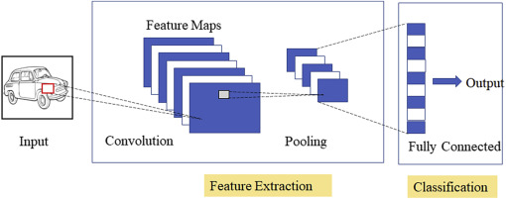

Figure 5 - An Illustration of a Typical CNN Network's Workflow [149]

The convolutional layer performs three distinct functions. The feature map is created due to the convolution mentioned above procedure. The second stage entails activating the elements contained in the feature map using a non-linear activation function, most frequently a rectified linear unit (ReLU). Convolution is a linear process in and of itself; the non-linearity is introduced by the ReLU activation functions used in the convolutional layers. ReLU is a piecewise linear function. They are easy to create and train because they behave similarly to linear functions.

When non-linear activation functions are used, propagating errors through multiple layers of a network frequently results in the so-called "vanishing gradient" problem, which prevents deep networks from effectively learning. This is overcome by using an activation function that exhibits the same properties as a linear function. As with sigmoid activation functions, the ReLU activation function compresses the inputs z, clamping negative values to zero, as illustrated in Figure 6.

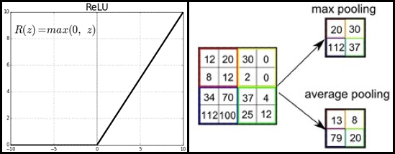

Figure 6 – The Activation Function for Rectified Linear Units [150], and Examples of Max and Average Pooling [151].

The third stage employs a pooling procedure to smooth and shrink the resulting feature map's dimensions. The max-pooling method is frequently used; it returns an array of the maximum output values contained within the rectangle neighbourhood of the previous layer [131]. Pooling layers are used to reduce the size of the previous layer's output. A single value denotes the pool constructed from the output of a specified pool of neighbouring neurons in the preceding layer. In other words, the pooling layer combines the responses from multiple areas to produce a single value. As illustrated in Figure 6, a max-pooling operation maintains the highest value contained within a region as the item to pass through to the next layer. As a result, the subsequent layer processes fewer inputs, increasing computing efficiency.

One or more convolutional layers may be present in a CNN network. After the convolutional layers generate their outputs, the hidden or fully connected layers receive them. The output layer is the next layer after the fully connected layer; it serves the same purpose as an output layer in a conventional neural network. Amaradinghe [2] et al. concluded that CNN is a viable technique capable of producing accurate load forecasts compared to LSTM, SVM, ANN, and other forecasters for individual building load forecasting.

### 2.4.3 LSTM and CNN as Load Forecasters

The authors of [148] examined seven distinct models using three real-world data sets and demonstrated that deep learning techniques could be employed in load forecasting applications in place of more traditional mathematical techniques such as ARIMA. The authors of [4] offered a novel parallel model that combines CNN and RNN. Similarly, the authors of [152] incorporated a mix of long short-term memory (LSTM) and convolutional neural networks (CNN). The proposed model outperformed the individual CNN and LTSM models in load forecasting stability. Similarly, the authors of [68] proposed a new Deep-Energy model for forecasting future load data that combines a 1-D CNN with a fully connected network [153]. They compared the performance of the proposed model to that of five different machine learning techniques, including the LSTM and ANN. The findings indicated that the Deep-Energy model could make accurate short-term load predictions better than the other models.

In another paper [154], the authors presented a new model that incorporates three forecasters: Variational Mode Decomposition (VMD), Convolutional Neural Networks (CNN), and Gated Neural Networks (GRU), and named it SEPNet. Compared to other models such as LSTM, CNN, and VMD-CNN, the SEPNet model outperformed them all, significantly improving the forecasts' overall performance. The ImageNet Large Scale Visual Recognition Competition (ILSVRC) is an annual international competition for computer vision. For the first time, a CNN won this competition in 2012 [155]–[163].

## 2.5 The Myth of Finding the One Size Fits All Technique

Tao Hong discussed the myth of discovering the optimal technique [1]. He concluded that researchers and users must understand that there is no universally superior technique. The approach taken with load forecasting should be determined by the forecasting requirements and the dataset under analysis. One approach is unlikely to be beneficial in all load forecasting scenarios. With different datasets, different forecasters perform better or worse. Additionally, forecast errors vary significantly across utilities, utility zones, and time horizons.

## 2.6 Peak Load

Base load refers to the bare minimum amount of electrical demand that must be met over a 24-hour period. Base load requirements are relatively constant and are also known as constant load. Conversely, peak load refers to the maximum amount of energy drawn from the grid by a consumer over a specified period. While most utilities run on a 15-minute cycle, some run on 30- or 60-minute cycles [164]. While there may be numerous spikes in energy demand over the time period, a peak load is defined as one that lasts at least 15 minutes; anything less than 15 minutes is considered a random spike. Demand spikes are typically caused by the activation of an electrical-consuming device and last only a few seconds.



Figure 7 – Peak Load vs Base Load [165]

Consider a house's electrical requirements. The base load is the amount of electricity constantly required from the electrical grid. When additional power is required, such as when an entire family is at home watching television and consuming a large amount of electricity, a peak load occurs. It is a momentary period of increased demand, as the family will soon be sleeping, turning off the television and lights, and conserving energy. The base load is more stable but also less intense, as electricity is still required for heating, cooling, and power outlets, among other things. Peak load is less predictable than base load. It can surge when air conditioners are switched on or when a snowstorm hits and the heat must be turned up [166].

Figure 7 depicts the visual distinction between the base and peak loads. Peaks have three distinct characteristics: magnitude, temporal location, and width or duration. The temporal location of the peak is the most critical of all the characteristics, even more so than the peak's value. Knowing the precise time that a peak will occur enables utilities to plan reserve power and demand response strategies to help reduce the peak, resulting in significant savings for both the utility and its customers. Understanding peak load is critical for any energy management strategy used by a business [167]. Generally, electricity is more expensive during peak periods. Forecasting peak loads is critical for ensuring sufficient generation, transmission, and distribution capacity. The peak load determines the rate charged by the utility to the customer. This study evaluated forecasters based on their daily peak accuracy, considering the peak's value and time of occurrence.

## 2.7 Performance Metrics

The performance of all forecasters was compared across all datasets, considering both overall performance and performance on an hourly, daily, monthly, and seasonal basis. It aided us in identifying instances in which forecasters outperformed or underperformed expectations. The performance was assessed based on forecast accuracy in general and accuracy in predicting daily peaks.

While the mean absolute error (MAE) is the simplest way to quantify forecast error [17], it cannot compare measurements across forecast scenarios with varying scales because it is an absolute measure. As a result, the mean absolute percent error (MAPE) is frequently used because comparisons are straightforward to interpret. MAPE is also the most frequently used metric for load forecasting [1]. The following table summarizes the most frequently used methods for determining accuracy:

|  |  |
| --- | --- |
|  |  |
|  |  |

Table 1 - Formulas for Several Frequently Used Performance Metrics

However, MAPE has limitations in that it cannot handle zero-valued actuals, it over-emphasizes high errors during periods of low demand, and it over-emphasizes overshoot errors in comparison to undershoot errors for forecasting scenarios bounded by 0 (since undershoot errors cannot exceed 100%, but overshoot errors are unbounded) [1], [168]. Both MAE and MAPE are insensitive to rare but significant errors, which are better captured by root mean square error (RMSE) [68], but RMSE is more difficult to interpret because it is not scaled to the original error. Mean Biased Error (MBE) and standard deviation (STD) can also be used to fully capture bias and precision [169], [170]. While these metrics have limitations, they are straightforward tools for assessing forecast accuracy.

This study concentrated on the MAPE and RMSE because they are the most frequently used load forecasting metrics. Because our datasets contain no values near zero, the MAPE's limitations do not apply, and the RMSE enables us to detect significant forecast errors. Additionally, we examined the accuracy of daily peaks using the MAPE, MAE, and MBE metrics. Appendix B of this document contains data on the overall performance of all metrics, including those mentioned above.

# 3 Investigation

The purpose of this work was to determine whether deep learning techniques could improve forecasting accuracy for specific utilities by comparing the accuracy of deep learning forecasters to some of the current forecasters used by utilities. This work focused on STLF horizons because they are a critical component of a utility system's day-to-day operations and planning. To accomplish this, a CNN forecaster and an LSTM forecaster were compared against four benchmark forecasters: a Seasonal Naive forecaster, a Multiple Linear Regression (MLR) forecaster, a Seasonal Auto-Regressive Integrated Moving Averages with Exogenous regressors (SARIMAX) forecaster, and a shallow Artificial Neural Network forecaster (ANN). The forecasting accuracy of the regular load and daily peaks was compared.

## 3.1 Preparation of the Datasets

This study was conducted using three distinct datasets. Figure 8 illustrates the daily mean for each data set for the year 2019. Two sets came from an Independent Electrical System Operator in Ontario and were included because the data sets are publicly available, which helps with the reproducibility of this work. One set is from Ottawa [171], and the other is from Toronto [171], and they both consist of city-wide load aggregation measurements taken hourly, spanning ten years from 2010-2019.

The third set comes from Saint John Energy, a municipally-owned utility reseller. This data set was included because the proposed work contributes to a larger Smart Grid Technologies project conducted at UNB in collaboration with this utility reseller. Saint John Energy's data set is smaller than the others, spanning approximately 3.75 years from 2018 to October 20, 2021, but otherwise corresponds to hourly measurements of Saint John's load aggregates. All load demand variables are expressed in megawatts (MW) for all datasets.

Temperature data from Environment Canada [172] were also incorporated to supplement the time series data. Hourly average temperatures for each city, expressed in degrees Celsius, were included.



Figure 8 – 2019 Average Daily Demand for Loads Across All Datasets

For both the load and temperature variables, a Hampel filter was used to locate and replace outliers in the datasets [173]. A seven-sample window (length = 7 hours) centred on the sample under test was used. Test samples values of more than three standard deviations from the median were discarded as outliers.

All data (load and temperature) were normalized using the Min-Max method, which scales values between zero and one using the time series’ minimum and maximum values, as specified in:



The minimum and maximum values were stored to be used to de-normalize the final forecasts before any performance metrics were calculated. Numerous researchers have used this technique of normalization in the field of load forecasting [25], [174]–[178].

Training and test sets were extracted from the data sets. The training period for both the Toronto and Ottawa datasets was January 2010–December 2018, and the testing period was January 2019–December 2019. The Saint John dataset was trained between January 1st, 2018, and October 20th, 2020, and tested between October 21st, 2020, and October 20th, 2021.

## 3.2 Implementation Specifications for Benchmark Forecasters

All forecasters were used to forecast the upcoming day based on the previous day’s data. Forecasts were generated day by day, using actual historical values. The forecasters were implemented using a recursive multi-step forecasting technique that forecasts one day at a time. In other words, we shifted our starting sample after the next day had passed, and now we have the actual demand for the day that just passed. We now employ inputs that forecast the following day based on the previous day's actuals. For the duration of our test datasets, this procedure was repeated daily.

### 3.2.1 The Seasonal Naïve Forecaster (SNF)

The seasonal naive forecaster was simple to implement; the forecasted value  was calculated using an actual load lag value  for lag l = 168 hours (1 week):



No training was required. This procedure was repeated for every hour in the test set.

### 3.2.2 The Multiple Linear Regression Forecaster (MLR)

The MLR forecaster was implemented using ten independent variables (inputs) as listed in Table 2. The model estimated a total of 56 coefficients, which included an intercept, a linear term for each independent variable, and products of distinct independent variable pairs (no squared terms) as delineated in Equation 6:



where  is the predicted load, are the variables,  are coefficients estimated by the model, and is an error term. Temperature and load demand variables are normalized quantities.

|  |  |
| --- | --- |
| **Variable Name** | **Variable Description** |
| Temperature (x1) |  |
| Hour of the Day (x2) | 1 … 24 |
| The month of the Year (x3) | 1 … 12 |
| Day of the Week (x4) | Sunday is 1, …, Saturday is 7 |
| Weekend Indicator (x5) | 0 or 1 |
| Maximum Hourly Demand from the Previous Day (x6) | Load Demand |
| Minimum Hourly Demand from the Previous Day (x7) | Load Demand |
| Average Hourly Demand from the Previous Day (x8) | Average Load Demand |
| Load Demand Lag Value for Lag = 24 Hours (1 Day) (x9) | Load Demand |
| Load Demand Lag Value for Lag = 168 Hours (1 Week) (x10) | Load Demand |

Table 2 - The MLR Forecaster's Independent Variables

Fitting the model to the training data was performed using the ordinary least squares algorithm [179]. Once the model was fully specified, it was used to forecast a value for every hour in the test set.

### 3.2.3 The Seasonal Auto-Regressive Integrated Moving Averages with Exogenous Regressors Forecaster (SARIMAX)

This study used the SARIMAX model, a modified version of the ARIMA model that considers seasonality and includes temperature as an exogenous variable. The equation below represents the SARIMAX model mathematically; it is repeated here for context.



|  |  |
| --- | --- |
| **Dataset** | **(p, d, q) x (P, D, Q, S)** |
| Toronto | (1, 1, [1, 2]) x ([24, 48, 72, 168], 24, [24, 168], 24) |
| Ottawa | (1, 1, 1) x ([24, 48], 24, [24, 168], 24) |
| Saint John | ([1, 2], 1, 1) x ([24, 168], 24, [24, 48], 24) |

Table - The SARIMAX hyperparameters that were used across all datasets

To specify the hyperparameters of the SARIMAX forecaster, we used a trial-and-error approach guided by autocorrelation (AC) and partial autocorrelation (PAC) plots. The parameters of each data set are denoted by SARIMAX (p, d, q) x (P, D, Q, S), where p, d, and q denote the nonseasonal component of the AR part's lag vector, the degree of differentiation, and the MA part's lag vector, respectively. S denotes seasonality in hours, while P, D, and Q denote seasonal parameters similar to non-seasonal parameters. Table 3 summarizes the parameters for each dataset; the numbers indicate the precise lags used. Appendix A contains the AC and PAC plots used to justify these choices.

The model was fitted for each forecasted day using the previous 28 days' demand and temperature values, resulting in a unique model generated for each day. The model was fitted using the parameters listed above; a constant term was also included. Following that, the model was used to estimate the coefficients. The model was fitted using the expectation-maximization algorithm. For innovation, we used the student's t conditional probability distribution. Additionally, we discovered that employing this distribution rather than the Gaussian distribution improved performance. After developing the model, it was used to forecast hourly values for the following day, with the upcoming day's temperature used as an exogenous variable.

### 3.2.4 The Artificial Neural Network Short Term Load Forecaster (ANNSTLF-G3)

Figure 9 depicts the architecture for both the BLF and CLF used in the ANNSTLF-G3 implementation. Both ANNs were fully connected across all layers; the hidden layer comprised sixty neurons. The activation function was a hyperbolic tangent sigmoid transfer function in both the hidden and output layers. Eighty percent of the training data was used to train the ANNs, while twenty percent was used for validation to avoid overtraining. We divided the data randomly, using randomly generated indices for the training and validation sets. The ANNs used gradient descent with momentum weight and bias learning function, and a dot product was performed on the weights for each input.



Figure 9 – The Structure of the BLF and CLF Network

Each of the BLF and CLF required 79 inputs. The inputs to both ANNs were identical and are depicted in the figure above, where k+1 represents the day to be predicted, and k represents the previous day. The BLF was trained to output load demands for each hour of day k+1, while the CLF was trained to output hourly changes in load demand from day k to day k+1. During training, the BLF was presented with actual load demand for day k+1, whereas the CLF was presented with the difference in actual loads from day k+1 to day k. Both the BLF and CLF networks were trained using the back-propagation algorithm.

Each ANN's output was fed into the RLS combiner, producing a fine-tuned hourly load prediction. Prior to presenting the CLF outputs, they were supplemented with actual loads from day k to reflect a load prediction rather than a change in load. The RLS combiner was initialized to equally combine outputs from both ANNs (i.e., weights were set to 0.5). After each iteration, the weights for each hour were updated using a least-squares algorithm.

When we switched between resilient and Levenberg-Marquardt back-propagation, we observed that resilient back-propagation outperformed Levenberg-Marquardt back-propagation. We observed a performance improvement when we changed the activation function of the output layer from linear to tangent sigmoid. We also observed better forecasting performance when we divided the data using random indices rather than blocks.

## 3.3 Implementation Specifications for the Deep Learning Forecasters

### 3.3.1 The Long Short Term Memory Forecaster (LSTM)

Another researcher from UNB's smart-grid team forecasted load using the LSTM forecaster, but only on the Saint John dataset. We modified his implementation to include all of our datasets and feature sets. We trained the LSTM models using the adam optimization training algorithm. The LSTM network was composed of four layers: a sequence input layer with 79 inputs, an LSTM layer with 100 hidden units, a fully connected layer with 24 outputs, and a regression layer. Between time steps, the amount of data retained is proportional to the number of hidden units (the hidden state); this was the optimal value for all datasets examined [180].

Additionally, because the ANNSTLF structure was identified as the best forecaster for short-term load forecasting [1], [84], we emulated the ANNSTLF structure by developing a Base Load Forecaster (BLF), a Change in Load Forecaster (CLF), and an RLS combiner using the LSTM forecaster rather than the ANN. The inputs and structure of the architecture were identical to those of the ANNSTLF, but the BLF and CLF forecasters were trained using LSTMs. Utilizing the architecture resulted in superior results overall and across multiple timeframes.

### 3.3.2 The Convolutional Neural Network Forecaster (CNN)

The CNNs in this study consist of six layers: an input layer with 79 input features, a convolutional layer with a filter size of 6 pixels in height, 5 pixels in width, and 15 filters in total, a rectified linear unit activation layer (ReLU), a max-pooling layer with a pool size of 2 pixels in height and 1 pixel in width, a fully connected layer with 24 responses, and a regression output layer.

As with the LSTM models, the CNN models were trained using the adam optimization training algorithm. Additional information about this algorithm can be found in [181]. We implemented the CNN forecaster similarly to the LSTM forecaster using the ANNSTLF structure, and as a result of using this architecture, we observed improved results overall and across all timeframes.

## 3.4 Method Analysis

MATLAB version R2021b was used to implement all forecasters. Our goal was to forecast the following day's load and identify daily peaks. For the overall regular load forecasts, we calculated the MAPE and the RMSE. A word about forecasters, which combine the outputs of two distinct models, the BLF and the CLF, using an RLS combiner. The RLS combiner results were used; the forecasters in question are CNN, LSTM, and ANN.

To determine daily peak accuracy, we used the mean absolute percent error (MAPE), the mean absolute error (MAE), and the mean biased error (MBE). We used the MAPE metric to determine the magnitude difference between the actual and forecasted peak values. The MBE and MAE metrics were used to calculate the time difference between the highest load aggregation occurrences in an hour. We included both the MAE and the MBE because the MBE can result in skewed results when positive and negative time differences cancel out. The MAE would be used to determine the accuracy of the time difference, whereas the MBE would be used to determine the models' bias in general, whether they over or under forecast based on the time of occurrence. It is worth noting that the MAEs and MBEs of the time difference are denoted in the tables by minutes. Appendix B contains a brief note regarding our peak detection accuracy metrics.

## 3.5 The Performance of Forecasters on the Toronto Dataset

Figure 10 depicts a snapshot of actual and forecasted load demand for July 17th to July 21st; this period was chosen because it coincided with the month in which all forecasters performed the worst overall. Figure 10 also depicts the overall distribution of errors, while Table 4 summarizes the key performance metrics. Table 5 summarizes the forecaster's performance in predicting daily peaks.

|  |  |  |  |  |  |  |
| --- | --- | --- | --- | --- | --- | --- |
| **Metrics** | **CNN** | **LSTM** | **ANN** | **MLR** | **SARIMAX** | **SNF** |
| **MAPE (%)** | 2.16 | 2.54 | 2.30 | 3.75 | 4.00 | 6.09 |
| **RMSE (MW)** | 189.76 | 219.57 | 201.32 | 293.94 | 321.58 | 488.07 |

Table 4 - Overall MAPE and RMSE for Each Forecaster – Toronto Dataset

|  |  |  |  |  |  |  |
| --- | --- | --- | --- | --- | --- | --- |
| **Metrics** | **CNN** | **LSTM** | **ANN** | **MLR** | **SARIMAX** | **SNF** |
| **MAPE - Peak Values** | 2.36 | 2.76 | 2.45 | 3.65 | 4.41 | 6.18 |
| **MAE - Time in Minutes** | 80 | 90 | 93 | 96 | 93 | 92 |
| **MBE - Time in Minutes** | 22 | 6 | -9 | 36 | 17 | 0 |

Table - Matrix Analysis of Peak Values and Time Difference – Toronto Dataset

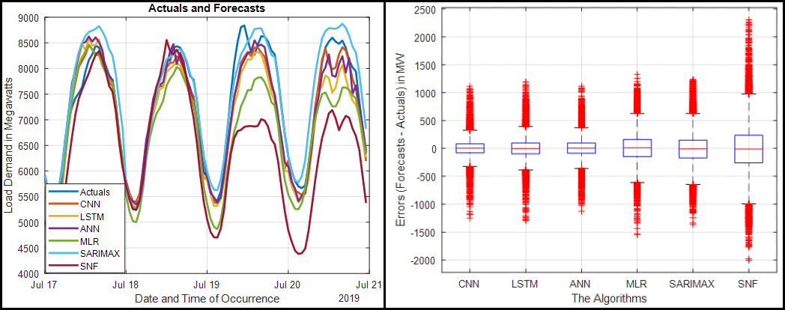

Figure 10 - Actual and Forecasted Load Demand for July 17th - 21st, and the Overall Error Distribution for All Forecasters - Toronto Dataset

### 3.5.1 Discussion of the Toronto Dataset's Overall Performance

When we look at Table 4, we can see how the forecasters performed overall on the Toronto dataset. The CNN had the lowest MAPE and RMSE values, followed by the ANN and LSTM. Similarly, when we examine the plot in Figure 10, we can observe the same. Additionally, the CNN forecaster had the smallest error distribution among all the forecasters. The SNF forecaster produced the worst results, with the broadest error distribution and the worst global metrics.

The CNN was the most accurate at predicting the magnitude of daily peaks, followed by the ANN and LSTM, as indicated by the MAPE values in Table 5. The MAE values indicate that the CNN predicted the most accurate time prediction, followed by the LSTM. The MBE values indicate that the SNF and LSTM were the most precise in terms of bias.

## 3.6 The Performance of Forecasters on the Ottawa Dataset

Figure 11 depicts a snapshot of actual and forecasted load demand for July 17th to July 21st; this period was chosen because it coincided with the month in which all forecasters performed the worst overall. Figure 11 also depicts the overall distribution of errors, while Table 6 summarizes the key performance metrics. Table 7 summarizes the forecaster's performance in predicting daily peaks.

|  |  |  |  |  |  |  |
| --- | --- | --- | --- | --- | --- | --- |
| **Metrics** | **CNN** | **LSTM** | **ANN** | **MLR** | **SARIMAX** | **SNF** |
| **MAPE (%)** | 2.72 | 3.44 | 3.09 | 4.78 | 4.98 | 7.33 |
| **RMSE (MW)** | 37.13 | 46.82 | 41.93 | 65.77 | 68.58 | 102.83 |

Table 6 - Overall MAPE and RMSE for Each Forecaster – Ottawa Dataset

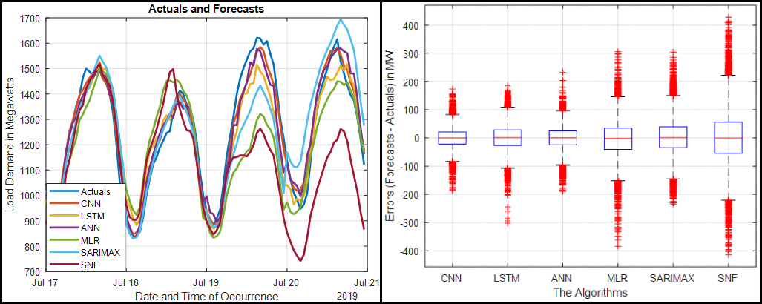

Figure 11 - Actual and Forecasted Load Demand for July 17th - 21st, and Overall Error Distribution for All Forecasters - Ottawa Dataset

|  |  |  |  |  |  |  |
| --- | --- | --- | --- | --- | --- | --- |
| **Metrics** | **CNN** | **LSTM** | **ANN** | **MLR** | **SARIMAX** | **SNF** |
| **MAPE - Peak Values** | 2.38 | 3.10 | 2.78 | 4.21 | 4.77 | 6.98 |
| **MAE - Time in Minutes** | 52 | 69 | 64 | 70 | 61 | 79 |
| **MBE - Time in Minutes** | 13 | 22 | 16 | 35 | 39 | 0 |

Table 7 - Matrix Analysis of Peak Values and Time Difference – Ottawa Dataset

### 3.6.1 Discussion of the Ottawa Dataset's Overall Performance

As illustrated in Table 6, the overall performance of the Ottawa dataset is similar to that of the Toronto dataset. The CNN has the lowest MAPE and RMSE values, followed by the ANN and LSTM. The CNN has the narrowest error distribution, whereas the SNF has the worst overall performance metrics and the widest error distribution in the boxplot above.

According to MAPE values in Table 7, the CNN was also the most accurate at predicting the magnitude of daily peaks, followed by the ANN and LSTM. The MAE values indicate that the CNN predicted the time most accurately. According to the MBE values, the SNF and CNN were the most precise in terms of bias.

## 3.7 The Performance of Forecasters on the Saint John Dataset

Figure 12 illustrates a snapshot of actual and forecasted load demand for December 17th to December 21st; this period was chosen because it corresponded to the month during which all forecasters performed the worst overall. also depicts the overall distribution of errors, while summarizes the key performance metrics. summarizes the forecaster's performance in predicting daily peaks.

|  |  |  |  |  |  |  |
| --- | --- | --- | --- | --- | --- | --- |
| **Metrics** | **CNN** | **LSTM** | **ANN** | **MLR** | **SARIMAX** | **SNF** |
| **MAPE (%)** | 3.89 | 4.55 | 4.33 | 6.11 | 5.33 | 9.39 |
| **RMSE (MW)** | 8.06 | 8.95 | 8.29 | 11.06 | 10.82 | 16.90 |

Table 8 - Overall MAPE and RMSE for Each Forecaster – Saint John Dataset

|  |  |  |  |  |  |  |
| --- | --- | --- | --- | --- | --- | --- |
| **Metrics** | **CNN** | **LSTM** | **ANN** | **MLR** | **SARIMAX** | **SNF** |
| **MAPE - Peak Values** | 3.71 | 4.07 | 3.90 | 5.42 | 5.28 | 8.34 |
| **MAE - Time in Minutes** | 160 | 180 | 175 | 191 | 185 | 209 |
| **MBE - Time in Minutes** | 13 | 4 | 9 | -14 | -19 | -2 |

Table - Matrix Analysis of Peak Values and Time Difference – Saint John Dataset

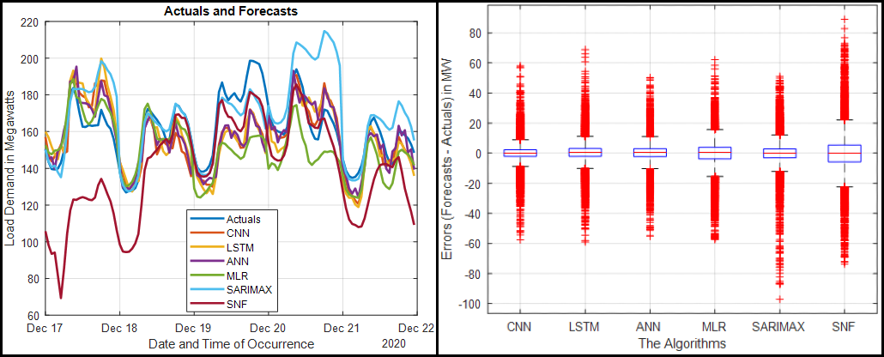

Figure 12 - Actual and Forecasted Load Demand for December 17th - 21st, and Overall Error Distribution for All Forecasters - Saint John Dataset

### 3.7.1 Discussion of the Saint John Dataset's Overall Performance

In , we can see how the forecasters fared across the entire Saint John dataset. The CNN performs best in MAPE and RMSE, followed by the ANN and LSTM. In general, the SNF forecaster underperformed, exhibiting the most skewed error distribution.

The CNN was the most accurate at predicting the magnitude of daily peaks, followed by the ANN and LSTM, as indicated by the MAPE values in Table 9. The MAE values indicate that the CNN, ANN, and LSTM models accurately predicted the time of occurrence in comparison to other forecasters. According to the MBE values, the SNF and LSTM models were the most precise in terms of bias.

## 3.8 Conclusion

According to the MAPE and RMSE values across all datasets, the CNN performed the best overall, followed by the ANN and LSTM. Furthermore, CNN appears to have the tightest error distribution of all forecasters. Across all datasets, the SNF performed the worst, with the broadest error distribution. The fact that the SNF forecaster performs the worst of all forecasters is encouraging, as it implies that all other forecasters added value to the forecasts.

When the magnitudes of the peaks are compared across all datasets, the CNN has the lowest MAPE values, followed by the ANN and LSTM. The MAE values indicate that the CNN forecasted the occurrence time more accurately than the other forecasters. The LSTM and ANN forecasters follow the CNN in the Toronto and Saint John datasets. However, according to the MAE values in the Ottawa dataset, the SARIMAX forecaster outperforms the LSTM and ANN.

As evidenced by the results in this chapter, CNN, LSTM, and ANN forecasters all perform admirably. They produce some promising results. In Chapter 4, we will examine each of these forecasters' performance on various datasets, emphasizing hourly, daily, monthly, and seasonal performance.

# 4 Comprehensive Evaluation of Our Forecasters' Performance

In Chapter 3, we assessed the overall performance of all forecasters by using regular load forecasts and daily peak load forecasts from all datasets. This section will analyze all dataset’s hourly, daily, monthly, and seasonal performance. Additionally, we will include a brief discussion following all of the above analyses that summarize our overall findings for each dataset. All variables relating to load demand are expressed in megawatts (MW), while the temperature variable is expressed in degrees celsius. To keep the scope of this thesis manageable, the boxplots of our top forecasters for each section are included here; additional box plots are included in appendix b.

It is also worth noting that the hours (00:00...23:00) are labelled as (1:00...24:00) in the hourly performance sections, with 1:00 denoting the first hour and 24:00 denoting the final hour of the day. In the later chapters of each dataset, we analyzed the forecasters' performance for the year's four seasons, namely Winter, Summer, Autumn, and Spring. December, January, and February are winter months. March, April, and May are considered spring. The summer months are June, July, and August. Autumn/Fall is defined as September, October, and November.

## 4.1 The Toronto Dataset

The Toronto dataset comprises hourly load aggregation measurements taken throughout the city from 2010 to 2019. The years 2010-2018 were used to train the forecasters, and 2019 was used to test them.

### 4.1.1 The Hourly Performance

Figure 13 illustrates the MAPE values for each forecaster when aggregated as hourly averages. The subsequent plots are boxplots of the hourly error distributions for CNN, LSTM, and ANN forecasters on an hourly timescale.

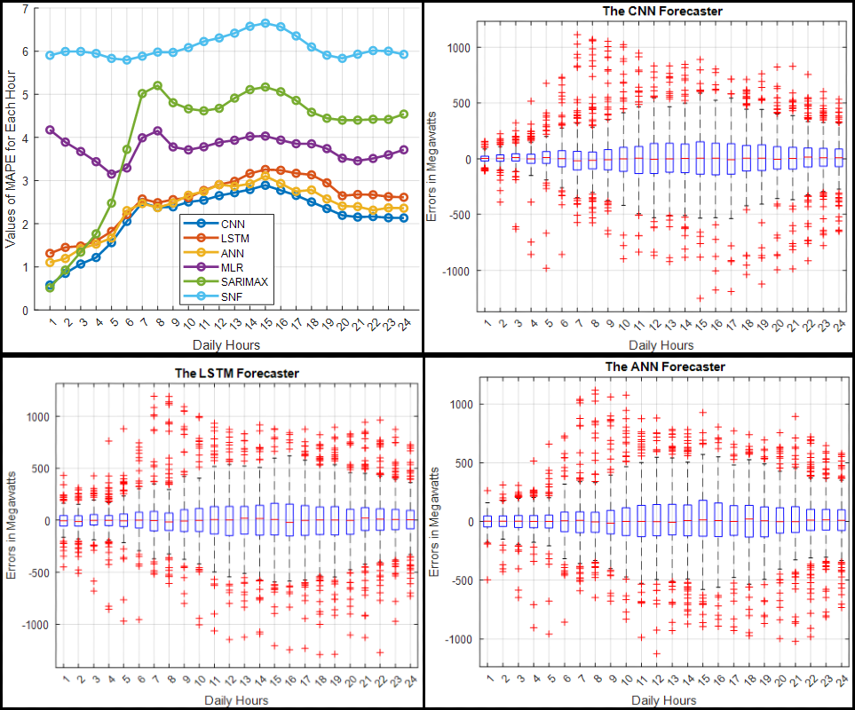

Figure 13 - Hourly MAPE and Hourly Error Distributions for CNN, LSTM, and ANN Forecasters – Toronto Dataset

#### 4.1.1.1 A Snippet on Hourly Performance

When we compare the average MAPE values in Figure 13 to the box plots, we observe a similar pattern of errors, with a broader distribution of errors in situations with higher MAPE values and vice versa. Overall, the CNN had the tightest error distribution and the lowest MAPE values for each hour of the day. The ANN and the LSTM forecasters followed it. All three forecasters made their worst predictions around 15:00. These forecasters predicted quieter times, such as around 1:00, much more accurately than busier times.

Overall, the SNF performed poorly in MAPE values and error distribution. The SNF's worst prediction occurred between 13:00 and 17:00, which is unsurprising given that it was based on previous week's values and that these are commonly used times for electricity. Based on the hourly MAPE values and the distribution of errors, we can conclude that CNN produced the best results.

### 4.1.2 The Daily Performance

Figure 14 shows the MAPE values for each forecaster aggregated as daily averages for each day of the week. The subsequent plots are boxplots of the daily error distributions for CNN, LSTM, and ANN forecasters on a daily timescale.

#### 4.1.2.1 A Snippet on Daily Performance

We compare the MAPE values in Figure 14 to the error distribution's boxplots. We can see that Monday was the worst day for forecasters across the board. Sundays were the second-worst days for CNN, LSTM, ANN, MLR, and SNF, while Saturday was the second-worst day for the SARIMAX. For forecasters, Tuesdays through Fridays were the most predictable days. On all seven days of the week, CNN's MAPE values were the lowest, and all of its boxplots were the narrowest. The ANN is ranked second, with the LSTM edging it out in Monday's predictions. The LSTM forecaster takes third place. The SNF performed the worst overall.

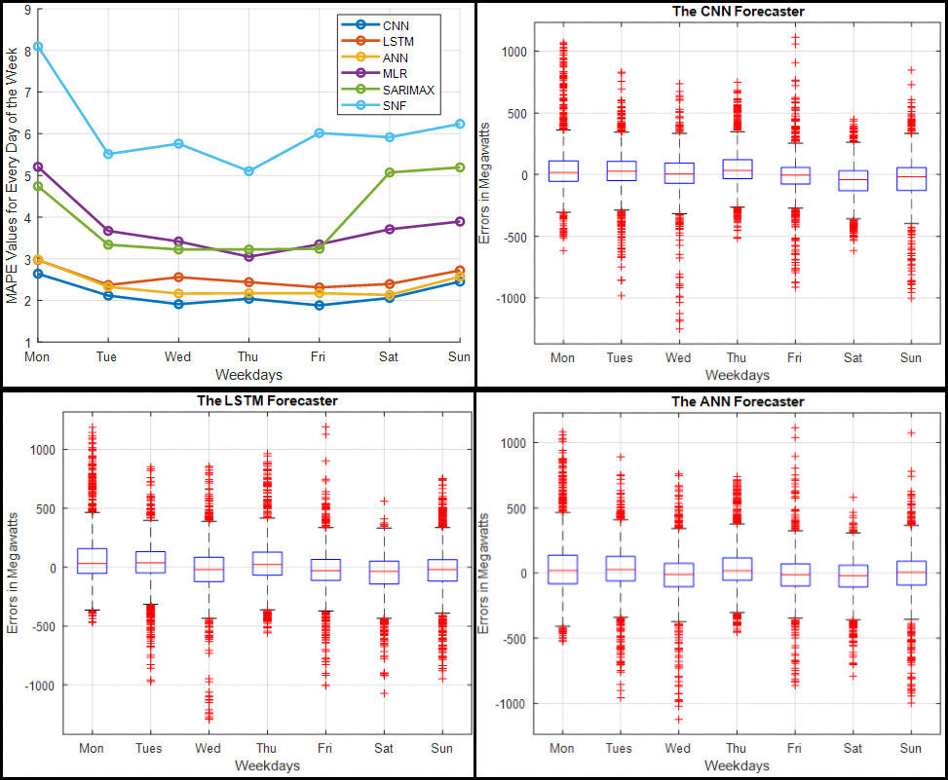

Figure 14 – Daily MAPE and Daily Error Distributions for CNN, LSTM, and ANN Forecasters – Toronto Dataset

##### 4.1.3 The Monthly Performance

The MAPE values for each forecaster are aggregated in Figure 15 as monthly averages for each month of the year 2019. The subsequent plots are boxplots of the monthly error distributions for CNN, LSTM, and ANN forecasters on a monthly timescale.

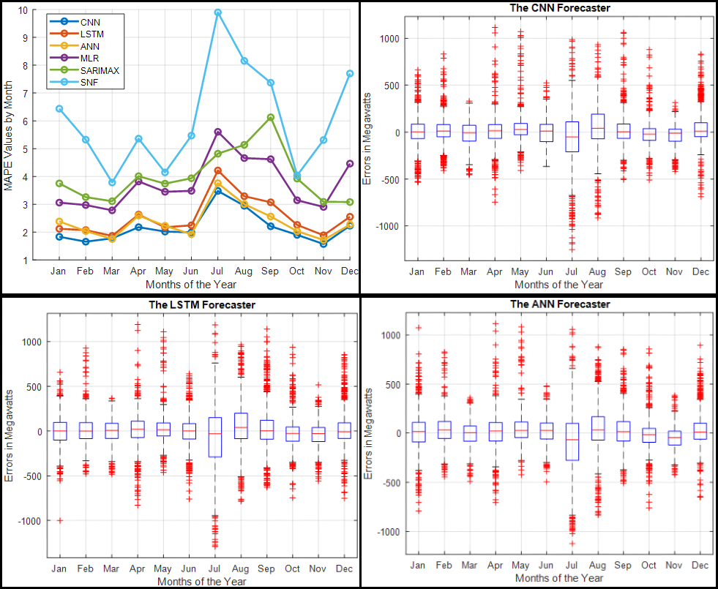

Figure 15 - Monthly MAPE and Monthly Error Distributions for CNN, LSTM, and ANN Forecasters – Toronto Dataset

#### 4.1.3.1 A Snippet on Monthly Performance

July was the most challenging month to forecast for all forecasters except the SARIMAX; September was the SARIMAX's worst-performing month. September forecasting proved to be equally challenging for the other forecasters. August was the second month in a row in which forecasters struggled to make accurate predictions. Forecasters found February, March, and November relatively easy to forecast. The CNN had the lowest MAPE values over ten months and was only outperformed by the ANN in March and June. The ANN is ranked second because it was only surpassed in January by the LSTM, whereas the LSTM is ranked third. The SNF had the highest MAPE values and the most skewed error distribution.

### 4.1.4 Performance During the Seasons

The table below summarizes the MAPE and RMSE values obtained for the average of various seasons in the Toronto test dataset. Summer was the most challenging season to predict for all forecasters. Across all four seasons, CNN had the lowest MAPE and RMSE values. The ANN is ranked second, having been only surpassed in the winter by the LSTM, which is ranked third. Autumn was the season with the lowest metric values for the CNN and ANN, whereas spring had the lowest metric values for the LSTM. Across all seasons, the SNF has the worst overall performance metrics.

|  |  |  |  |  |  |  |
| --- | --- | --- | --- | --- | --- | --- |
| **Winter** | | | | | | |
| **Metrics** | **CNN** | **LSTM** | **ANN** | **MLR** | **SARIMAX** | **SNF** |
| **MAPE (%)** | 1.92 | 2.25 | 2.26 | 3.43 | 3.37 | 6.55 |
| **RMSE (MW)** | 172.22 | 192.89 | 206.20 | 270.47 | 283.12 | 508.21 |
| **Spring** | | | | | | |
| **Metrics** | **CNN** | **LSTM** | **ANN** | **MLR** | **SARIMAX** | **SNF** |
| **MAPE (%)** | 1.99 | 2.22 | 2.16 | 3.35 | 3.62 | 4.42 |
| **RMSE (MW)** | 160.14 | 174.98 | 170.82 | 236.15 | 266.77 | 338.62 |
| **Summer** | | | | | | |
| **Metrics** | **CNN** | **LSTM** | **ANN** | **MLR** | **SARIMAX** | **SNF** |
| **MAPE (%)** | 2.82 | 3.26 | 2.93 | 4.60 | 4.64 | 7.87 |
| **RMSE (MW)** | 254.72 | 293.83 | 267.77 | 371.81 | 384.33 | 629.32 |
| **Autumn / Fall** | | | | | | |
| **Metrics** | **CNN** | **LSTM** | **ANN** | **MLR** | **SARIMAX** | **SNF** |
| **MAPE (%)** | 1.89 | 2.40 | 2.14 | 3.55 | 4.38 | 5.56 |
| **RMSE (MW)** | 153.31 | 195.48 | 166.36 | 272.44 | 337.96 | 430.89 |

Table 10 - Seasonal MAPE and RMSE for the Toronto Dataset

### 4.1.5 Comprehensive Analysis Discussion

The summer months between June and August saw the highest demand for electricity in the Toronto dataset; these were also the months during which the forecasters had the most difficulty forecasting, as illustrated in the seasonal and monthly timeframes section. July was the month with the highest demand and the month with the highest error rates across all forecasters. This can be attributed to two factors: first, the increased demand can be attributed to the fact that the summer air in Toronto is typically hot throughout the day, including evenings, necessitating air conditioning by almost everyone. Additionally, Toronto is a highly touristic city, and everyone wants to visit during the summer when the weather is nicer. August was the second month with the highest number of errors, for the same reasons as July.



Figure 16 - Scatter Plot of Load Demand versus Temperature – Toronto Dataset

As illustrated in Figure 16, the scatter plot demonstrates a strong correlation between demand and temperature. The highest demand occurs during the summer when the temperature is higher. The second-highest demand occurs when the temperature drops, particularly in the winter. Moreover, because demand is lowest in the spring and autumn, the forecasters found these times easier to predict. The SNF's overall accuracy indicates that load demand is relatively stable in the spring and autumn.

The city of Toronto's peak demand typically occurs between 16:00 and 21:00. The majority of forecasters found it easier to forecast quieter times, such as around midnight in the mornings, than to forecast busy times, such as late mornings and afternoons, when everyone is awake, and electricity demand is high. Mondays were the days that the forecasters had the most difficulty predicting; this may be due to a feature specific to this dataset, or that Monday is the first working day of the week. Forecasters predicted more accurately from Tuesday to Friday, which is the middle of the week. This could be because these days are more stable and have high similarities.

Across all periods and seasons, the CNN forecaster outperformed all other forecasters. The ANN and LSTM forecasters hold the second and third places, respectively. The SNF is ranked last due to its consistently poor performance across all periods and seasons.

## 4.2 The Ottawa Dataset

The Ottawa dataset comprises hourly load aggregation measurements taken throughout the city from 2010 to 2019. The years 2010-2018 were used to train the forecasters, and 2019 was used to test them.

### 4.2.1 The Hourly Performance

Figure 17 illustrates the MAPE values for each forecaster when aggregated as hourly averages. The subsequent plots are boxplots of the hourly error distributions for CNN, LSTM, and ANN forecasters on an hourly timescale.

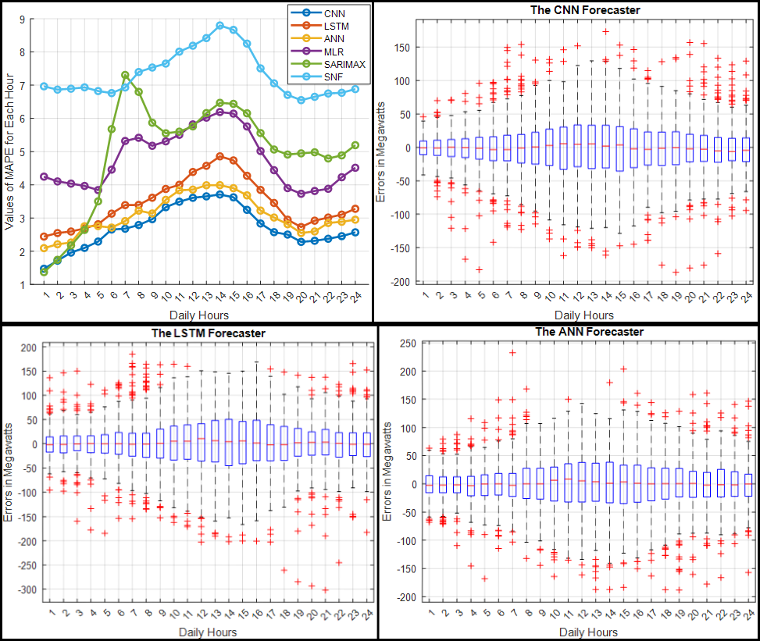

Figure 17 - Hourly MAPE and Hourly Error Distributions for CNN, LSTM, and ANN Forecasters – Ottawa Dataset

#### 4.2.1.1 A Snippet on Hourly Performance

When we compare the average MAPE values in Figure 17 to the box plots, we observe a similar pattern of errors, with a broader distribution of errors in cases where the MAPE value is more significant and vice versa. While the CNN had the tightest error distribution and lowest MAPE values for nearly every hour of the day, the SARIMAX outperformed it at 01:00. The ANN is the runner-up, with the LSTM outperforming it only during the 4:00 hour. Between 01:00 and 04:00 hours, the SARIMAX also outperforms the ANN. The LSTM is ranked third. Around 14:00, CNN, LSTM, and ANN all made their worst predictions. They predicted quieter times, such as around 1:00, with greater accuracy than busier times. The SNF performs poorly overall, outperforming the SARIMAX only at 7:00 when the SARIMAX makes its worst predictions.

### 4.2.2 The Daily Performance

Figure 18 shows the MAPE values for each forecaster aggregated as daily averages for each day of the week. The subsequent plots are boxplots of the daily error distributions for CNN, LSTM, and ANN forecasters on a daily timescale.

#### 4.2.2.1 A Snippet on Daily Performance

When we compare the MAPE values in Figure 18 to the boxplots of the error distribution. As can be seen, Saturdays and Mondays are the most difficult days to forecast for almost all forecasters, except the SARIMAX, which had its worst day on Saturday. Tuesdays through Fridays had a higher degree of predictability. The CNN's MAPE values were the lowest on all seven days of the week, and all of its boxplots were the narrowest. The ANN comes in second place, while the LSTM comes in third. The SNF performed the worst overall.

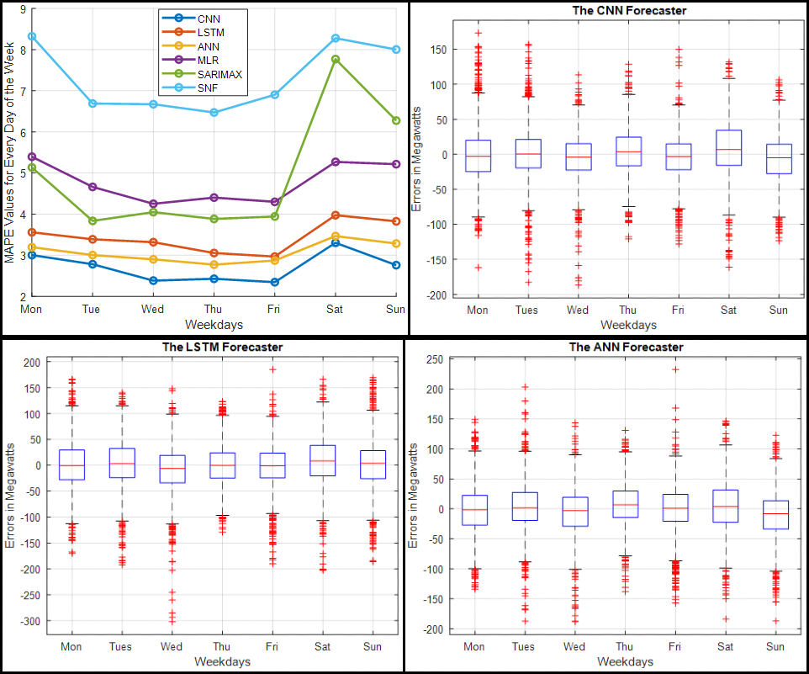

Figure 18 - Daily MAPE and Daily Error Distributions for CNN, LSTM, and ANN Forecasters – Ottawa Dataset

### 4.2.3 The Monthly Performance

The MAPE values for each forecaster are aggregated in Figure 19 as monthly averages for each month of the year 2019. The subsequent plots are boxplots of the monthly error distributions for CNN, LSTM, and ANN forecasters on a monthly timescale.

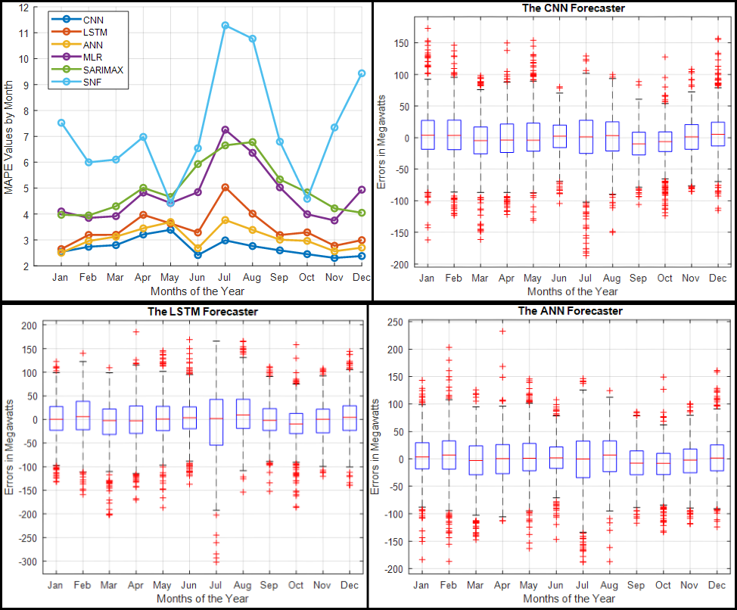

Figure 19 - Monthly MAPE and Monthly Error Distributions for CNN, LSTM, and ANN Forecasters – Ottawa Dataset

#### 4.2.3.1 A Snippet on Monthly Performance

When comparing the MAPE values in Figure 19 to the box plots, it becomes clear that July was the most challenging month to forecast using all forecasters except CNN. CNN determined that July is a relatively easy month, with April and May being the most difficult. The CNN has the lowest MAPE values and the narrowest error distribution across almost all months; it is only surpassed in January by the ANN. The ANN is ranked second, surpassed by the LSTM in May. The LSTM comes in third place. For most forecasters, January to March and October to November were relatively straightforward forecasting periods. Overall, the SNF performed poorly; it only outperformed the SARIMAX in May and October.

### 4.2.4 Performance During the Seasons

The table below summarizes the MAPE and RMSE values obtained for the average of various seasons in the Ottawa test dataset. CNN and ANN made their most dire predictions in the spring. All other forecasters, including the LSTM, struggled with the summer months. The LSTM and ANN had the easiest time forecasting the winter months. In Autumn, CNN and MLR make their best predictions. All preceding observations were made using MAPE values rather than RMSE values to facilitate interpretation. However, CNN had the lowest MAPE and RMSE values across all four seasons. The ANN is ranked second, while the LSTM is ranked third. Across all seasons, the SNF had the worst overall performance metrics.

|  |  |  |  |  |  |  |
| --- | --- | --- | --- | --- | --- | --- |
| **Winter** | | | | | | |
| **Metrics** | **CNN** | **LSTM** | **ANN** | **MLR** | **SARIMAX** | **SNF** |
| **MAPE (%)** | 2.55 | 2.94 | 2.86 | 4.30 | 3.99 | 7.73 |
| **RMSE (MW)** | 39.68 | 43.83 | 43.37 | 63.71 | 62.66 | 111.73 |
| **Spring** | | | | | | |
| **Metrics** | **CNN** | **LSTM** | **ANN** | **MLR** | **SARIMAX** | **SNF** |
| **MAPE (%)** | 3.13 | 3.60 | 3.43 | 4.39 | 4.65 | 5.83 |
| **RMSE (MW)** | 40.02 | 46.08 | 43.29 | 55.12 | 59.98 | 76.45 |
| **Summer** | | | | | | |
| **Metrics** | **CNN** | **LSTM** | **ANN** | **MLR** | **SARIMAX** | **SNF** |
| **MAPE (%)** | 2.72 | 4.12 | 3.22 | 6.17 | 6.46 | 9.57 |
| **RMSE (MW)** | 37.62 | 56.78 | 43.97 | 86.15 | 87.49 | 131.76 |
| **Autumn / Fall** | | | | | | |
| **Metrics** | **CNN** | **LSTM** | **ANN** | **MLR** | **SARIMAX** | **SNF** |
| **MAPE (%)** | 2.45 | 3.09 | 2.91 | 4.26 | 4.80 | 6.22 |
| **RMSE (MW)** | 30.42 | 38.51 | 35.85 | 52.51 | 60.04 | 81.81 |

Table 11 - Seasonal MAPE and RMSE for the Ottawa Dataset

### 4.2.5 Comprehensive Analysis Discussion

Ottawa's dataset is similar to Toronto's but contains some significant differences. The highest average demand occurred in January, February, July, and December. July proved to be the most challenging month to forecast for all forecasters except CNN. July was ranked third most difficult month by CNN, behind April and May. For the ANN and CNN, the most challenging season to forecast was spring; summer came in second. Summer was the most challenging season for all other forecasters, including the LSTM. Winter was the easiest season for the LSTM and the ANN.



Figure - Scatter Plot of Load Demand versus Temperature – Ottawa Dataset

Figure 20 depicts a scatter plot for the Ottawa dataset similar to the one for the Toronto dataset. They appear identical, but the Ottawa scatterplot has nearly the same level of demand during the winter and summer, when temperatures were cold and hot, respectively. In comparison, demand is significantly higher in the summer months in the Toronto dataset than it is in the winter months.

In the Ottawa dataset, the average peak demand occurs between 16:00 and 21:00. Except for SARIMAX, all forecasters made their worst predictions between 11:00 and 16:00, when most people are awake and using electricity or working at their jobs. Mondays and Saturdays were the most difficult days to predict for the forecasters, which may be because Monday is the first working day of the week and Saturday is the first day of the weekend. Sundays posed a challenge for the forecasters, but Mondays and Saturdays posed the greatest challenge. The middle of the week, specifically Tuesdays to Fridays, was the easiest period to forecast for all forecasters.

Across all periods and seasons, the CNN forecaster outperformed all other forecasters. The ANN and LSTM forecasters come in second and third place, respectively. The SNF is ranked last due to its poor performance across all periods and seasons; it only outperformed the SARIMAX in a few cases.

## 4.3 The Saint John Dataset

The Saint John dataset consists of hourly load aggregation measurements collected throughout the city between January 2018 and October 2021. The forecasters were trained between January 2018 and October 20th, 2020, and tested between October 21st, 2020, and October 20th, 2021.

### 4.3.1 The Hourly Performance

Figure 21 illustrates the MAPE values for each forecaster when aggregated as hourly averages. The subsequent plots are boxplots of the hourly error distributions for CNN, LSTM, and ANN forecasters on an hourly timescale.

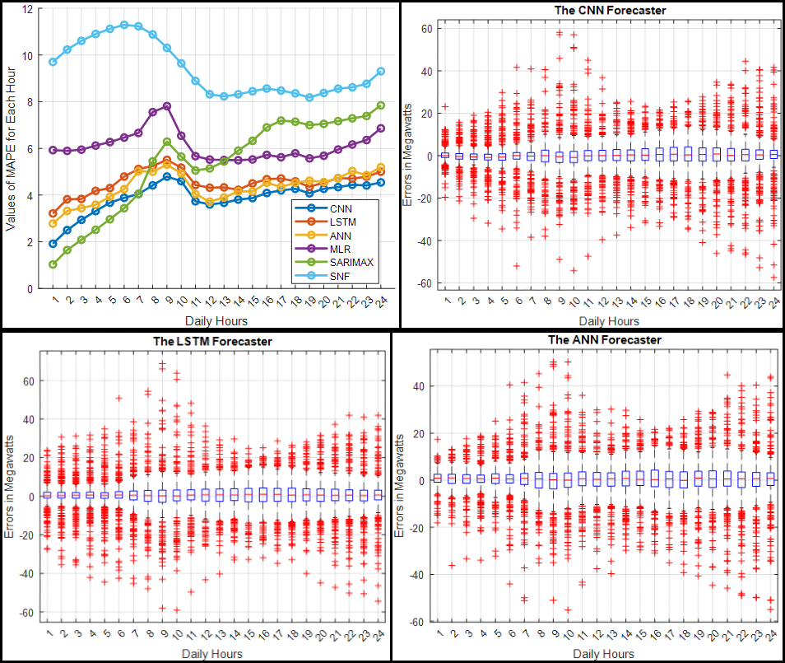

Figure 21 - Hourly MAPE and Hourly Error Distributions for CNN, LSTM, and ANN Forecasters – Saint John Dataset

#### 4.3.1.1 A Snippet on Hourly Performance

Saint John's peak demand occurs between 10:00 and 13:00, while the second peak occurs at approximately 19:00. When we compare the average MAPE values in Figure 21 to the box plots, we see a similar pattern of errors, with a broader distribution of errors in cases where the MAPE value is more significant and vice versa. Except for the SNF and SARIMAX, all forecasters had their worst performance around 9:00; the SNF had its worst performance around 6:00, and the SARIMAX had its worst performance around 24:00.

Between 1:00 and 6:00, the SARIMAX forecaster made the most accurate predictions; however, as demand increased throughout the day, the SARIMAX forecaster lost out to CNN. CNN performed best between the hours of 6:00 and 24:00 and during the day's peak hours. As a result, CNN had the best overall performance and the most tightly distributed errors. The ANN comes in second, with the SARIMAX outperforming it between 06:00 and 07:00 and the LSTM outperforming it between 19:00 and 22:00. The LSTM comes in third place. The SNF had the worst overall performance.

### 4.3.2 The Daily Performance

Figure 22 shows the MAPE values for each forecaster aggregated as daily averages for each day of the week. The subsequent plots are boxplots of the daily error distributions for CNN, LSTM, and ANN forecasters on a daily timescale.

#### 4.3.2.1 A Snippet on Daily Performance

When we compare the MAPE values in Figure 23 to the boxplots of the error distribution, we see that the forecasters had the most difficulty predicting Mondays and Saturdays. Wednesdays and Thursdays had the highest degree of predictability. CNN was the best performer on all seven days of the week. The ANN is second, only being outperformed on Fridays by the LSTM, and the LSTM is third, only being outperformed on Thursdays by the SARIMAX. The SNF had the worst overall performance.

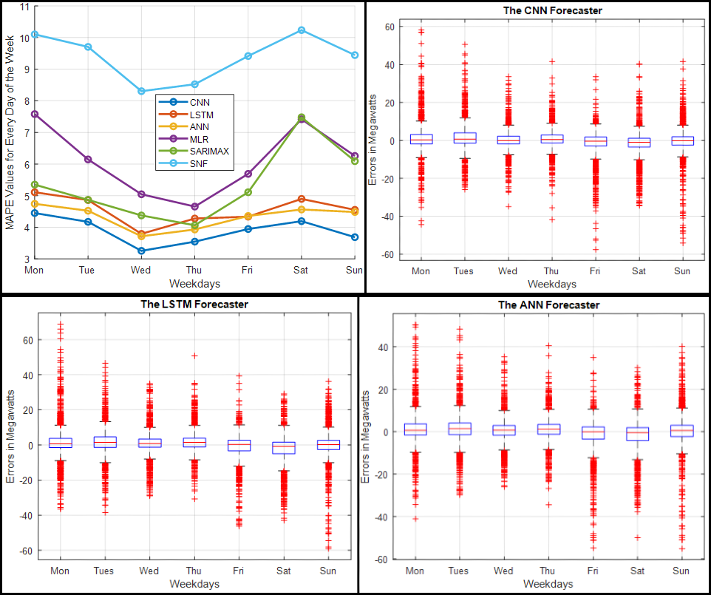

Figure 22 - Daily MAPE and Daily Error Distributions for CNN, LSTM, and ANN Forecasters – Saint John Dataset

### 4.3.3 The Monthly Performance

The MAPE values for each forecaster are aggregated in Figure 23 as monthly averages for each month of the year 2019. Boxplots of monthly error distributions for CNN, LSTM, ANN, and SARIMAX forecasters on a monthly timescale are shown in Figure 24.



Figure 23 - Monthly MAPE for Each Forecaster – Saint John Dataset

#### 4.3.3.1 A Snippet on Monthly Performance

The city of Saint John experiences its highest demand during the winter months. December was the month in which the majority of algorithms, except for SARIMAX and SNF, made their worst predictions. The SARIMAX forecaster produced the most accurate forecasts in January, November, and December. CNN's forecasts for the remaining months of the year were the most accurate.

The ANN and LSTM are inextricably linked, making it difficult to determine which produces more accurate predictions. The ANN outperformed the LSTM in January, February, April, September, October, and December. The LSTM outperformed the ANN in March, May, June, July, August, and November. Furthermore, the MLR and SNF outperformed the ANN in June. The SARIMAX outperforms the MLR in April. For the SNF, the most error-prone months were January to May and October to December.

Each forecaster performs similarly to the others, with one outperforming the others one month and the others the next. As a result, ranking them from first to third is difficult, as forecasters such as SARIMAX performed better during the winter months but less well during the rest of the year. While CNN made the most accurate predictions during the remaining nine months of the year, it cannot be declared the winner, as the SARIMAX's best months coincide with the highest demand months. The SNF outperformed some forecasters during hot months but struggled during cold months.

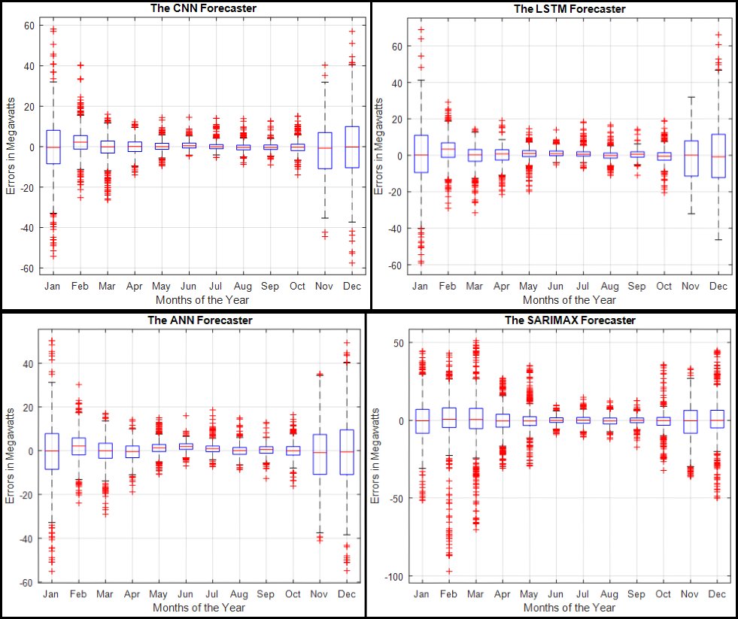

Figure - Monthly Error Distribution for CNN, LSTM, ANN, and SARIMAX Forecasters – Saint John Dataset

### 4.3.4 Performance During the Seasons

The table below summarizes the MAPE and RMSE values obtained for the Saint John test dataset's average of various seasons. Except for SNF, all forecasters had their worst performance in the winter; SNF had its worst performance in the spring. As demand was at its lowest, summer was the most straightforward season for forecasters. CNN had the best overall performance for the four seasons, while the SNF had the worst.

|  |  |  |  |  |  |  |
| --- | --- | --- | --- | --- | --- | --- |
| **Winter** | | | | | | |
| **Metrics** | **CNN** | **LSTM** | **ANN** | **MLR** | **SARIMAX** | **SNF** |
| **MAPE (%)** | 6.67 | 7.79 | 6.64 | 9.41 | 6.89 | 12.70 |
| **RMSE (MW)** | 13.33 | 14.95 | 13.34 | 17.57 | 15.55 | 23.08 |
| **Spring** | | | | | | |
| **Metrics** | **CNN** | **LSTM** | **ANN** | **MLR** | **SARIMAX** | **SNF** |
| **MAPE (%)** | 2.79 | 3.24 | 3.22 | 6.54 | 6.70 | 13.75 |
| **RMSE (MW)** | 4.41 | 4.99 | 4.81 | 9.24 | 12.27 | 20.41 |
| **Summer** | | | | | | |
| **Metrics** | **CNN** | **LSTM** | **ANN** | **MLR** | **SARIMAX** | **SNF** |
| **MAPE (%)** | 2.09 | 2.47 | 2.84 | 2.94 | 2.98 | 3.20 |
| **RMSE (MW)** | 2.20 | 2.65 | 2.75 | 2.97 | 3.03 | 3.36 |
| **Autumn / Fall** | | | | | | |
| **Metrics** | **CNN** | **LSTM** | **ANN** | **MLR** | **SARIMAX** | **SNF** |
| **MAPE (%)** | 4.09 | 4.76 | 4.68 | 5.62 | 4.78 | 7.95 |
| **RMSE (MW)** | 7.74 | 8.23 | 8.29 | 9.48 | 8.29 | 13.66 |

Table 12 - Seasonal MAPE and RMSE for the Saint John Dataset

### 4.3.5 Comprehensive Analysis Discussion

Saint John's dataset is quite distinct from those in Toronto and Ottawa. As illustrated in the scatter plot below, the Saint John dataset experiences the highest load demand during the winter months when temperatures are at their lowest, while demand was relatively low during the year's remaining months. Summer months have the lowest load demand for this dataset. As a result, the winter months were the most difficult to predict for most forecasters, while the summer months were the simplest.



Figure 25 - Scatter Plot of Load Demand versus Temperature – Saint John Dataset

In some winter months with the highest demand, such as January, November, and December, the SARIMAX forecaster made the most accurate predictions. Conversely, CNN made the most accurate predictions for the year's remaining months. This indicates that the SARIMAX forecasts can serve as a primary reference point for these specific months, while the CNN forecasts can be used for the year's remaining months.

Mondays and Saturdays were the most difficult days for the forecasters to predict, which may be due to the fact that Monday is the first working day of the week and Saturday is the first day of the weekend. Wednesdays and Thursdays were the most predictable days for the forecasters. The CNN had the best overall performance across all days of the week, followed by the ANN and LSTM.

The peak period of demand in Saint John is between 10:00 and 13:00. The majority of forecasters struggled to forecast around 9:00. Between 1:00 and 6:00, the SARIMAX forecaster made the most accurate predictions, but CNN made the most accurate predictions during the remaining hours of the day.

While CNN performed best on an hourly, daily, monthly, and seasonal basis, we should not overlook SARIMAX's accuracy during the majority of the winter months. The SNF had the worst overall performance. However, when demand was low and generally stable from June to September, the SNF outperformed a few forecasters.

# 5 Conclusion

## 5.1 Summary

We compared four benchmark forecasters to two deep learning techniques, CNN and LSTM, using three distinct datasets to determine the overall performance in forecasting regular load and daily peaks. CNN, LSTM, and ANN were the most accurate forecasters in overall accuracy. We then examined the performance of all forecasters across all datasets on hourly, daily, monthly, and seasonal predictions.

The CNN, ANN, and LSTM were ranked first, second, and third across all periods and seasons in the Toronto and Ottawa datasets. While CNN, ANN, and LSTM forecasters remained the best performers in the Saint John dataset, the SARIMAX forecaster outperformed them in January, November, and December. However, during the remainder of the year, the SARIMAX forecaster was not as accurate. This is expected, as forecasters perform differently across datasets and periods. The SNF's overall performance was the worst across all periods and seasons.

By and large, the CNN and LSTM performed admirably in forecasting the test datasets across all periods. There were numerous instances where the LSTM outperformed the ANN, and their predictions were generally quite similar. As an illustration, consider the monthly period of the Saint John dataset. In six months of the year, the LSTM outperformed the ANN. Therefore, we can conclude that deep learning techniques such as CNN and LSTM are effective and can assist researchers and utilities in improving load forecasting accuracy.

## 5.2 Contributions

Deep learning techniques are considered due to their extraordinary performance when applied to various problems; we evaluated the CNN and LSTM for their added value by comparing their performance to that of conventional forecasters; we compared accuracy in terms of both overall and peak detection. This study contributes to the maturation of the ongoing debate over the use of deep learning techniques in load forecasting that have not been thoroughly tested. We developed forecasters that are more adaptable to external factors such as annual increases in electricity demand or temperature shifts; we developed forecasters capable of automatically recognizing complex data relationships without explicit user input. We analyzed three distinct datasets; as we used publicly available data, this work is reproducible and will serve as a valuable benchmark for future research within and outside our smart-grid team.

## 5.3 Future Work

Several directions for future research include increasing forecaster accuracy, incorporating more exogenous variables, developing more complex forecasters that are hybrids or improved models of the ones used here, forecasting the width of daily peaks, implementing more deep learning forecasters, developing separate models to forecast different days and months (e.g., summer, winter), and utilizing a holiday indicator as an input that specifies which days are holidays and which are not. We will briefly discuss several of the points mentioned above.

Regarding forecasters' accuracy, we would recommend the following. The accuracy of the ANN, CNN, LSTM, and SARIMAX forecasters can be increased by including additional exogenous variables, such as those used by the MLR. These variables include the day's hour, the month, the weekend or holiday indicator, the previous day's maximum, minimum, and average demand, and the previous week's hourly lag. Along with temperature, weather variables such as humidity, dewpoint, and wind direction/speed can be used, depending on the analyst's objectives.

In terms of daily peaks, utilities benefit from knowing when the peaks will occur and how long they will last. As a result, another approach is to determine the width of demand peaks. Additionally, hybrid models incorporating CNNs, and LSTMs may also be an option, as some researchers have observed improved performance when the two are combined, as discussed in the deep learning section. Tao Hong et al. [1] also stated in their review paper that most of the best load forecasting techniques had been discovered to be hybrid models. Additionally, certain researchers have observed improved performance when distinct models are created to forecast specific days, such as weekdays and weekends, or specific months, such as winter and summer [52], [182].

As a result of the preceding paragraphs, we can see numerous possibilities and that additional research is necessary. These are pretty intriguing paths that could be taken, and they can assist utilities in the future in planning for and ensuring a stable supply of electricity to everyone.

Bibliography

[1] T. Hong and S. Fan, “Probabilistic electric load forecasting: A tutorial review,” *Int. J. Forecast.*, vol. 32, no. 3, pp. 914–938, 2016, doi: 10.1016/j.ijforecast.2015.11.011.

[2] K. Amarasinghe, D. L. Marino, and M. Manic, “Deep neural networks for energy load forecasting,” 2017, doi: 10.1109/ISIE.2017.8001465.

[3] C. Kuster, Y. Rezgui, and M. Mourshed, “Electrical load forecasting models: A critical systematic review,” *Sustainable Cities and Society*. 2017, doi: 10.1016/j.scs.2017.08.009.

[4] W. He, “Load Forecasting via Deep Neural Networks,” 2017, doi: 10.1016/j.procs.2017.11.374.

[5] J. Zheng, C. Xu, Z. Zhang, and X. Li, “Electric load forecasting in smart grids using Long-Short-Term-Memory based Recurrent Neural Network,” 2017, doi: 10.1109/CISS.2017.7926112.

[6] D. L. Marino, K. Amarasinghe, and M. Manic, “Building energy load forecasting using Deep Neural Networks,” *IECON Proc. (Industrial Electron. Conf.*, pp. 7046–7051, 2016, doi: 10.1109/IECON.2016.7793413.

[7] A. Almalaq and G. Edwards, “A review of deep learning methods applied on load forecasting,” *Proc. - 16th IEEE Int. Conf. Mach. Learn. Appl. ICMLA 2017*, vol. 2017-Decem, pp. 511–516, 2017, doi: 10.1109/ICMLA.2017.0-110.

[8] W. Kong, Z. Y. Dong, Y. Jia, D. J. Hill, Y. Xu, and Y. Zhang, “Short-Term Residential Load Forecasting Based on LSTM Recurrent Neural Network,” *IEEE Trans. Smart Grid*, vol. 10, no. 1, pp. 841–851, 2019, doi: 10.1109/TSG.2017.2753802.

[9] S. Saurabh, H. Shoeb, A. B. Mohammad, S. Singh, S. Hussain, and M. A. Bazaz, “Short term load forecasting using artificial neural network,” in *2017 4th International Conference on Image Information Processing, ICIIP 2017*, 2018, pp. 159–163, doi: 10.1109/ICIIP.2017.8313703.

[10] J. Zhang, Y. M. Wei, D. Li, Z. Tan, and J. Zhou, “Short term electricity load forecasting using a hybrid model,” *Energy*, 2018, doi: 10.1016/j.energy.2018.06.012.

[11] A. Rahman, V. Srikumar, and A. D. Smith, “Predicting electricity consumption for commercial and residential buildings using deep recurrent neural networks,” *Appl. Energy*, 2018, doi: 10.1016/j.apenergy.2017.12.051.

[12] B. Yildiz, J. I. Bilbao, and A. B. Sproul, “A review and analysis of regression and machine learning models on commercial building electricity load forecasting,” *Renewable and Sustainable Energy Reviews*. 2017, doi: 10.1016/j.rser.2017.02.023.

[13] A. Baliyan, K. Gaurav, and S. Kumar Mishra, “A review of short term load forecasting using artificial neural network models,” 2015, doi: 10.1016/j.procs.2015.04.160.

[14] I. K. Nti, M. Teimeh, O. Nyarko-Boateng, and A. F. Adekoya, “Electricity load forecasting: a systematic review,” *J. Electr. Syst. Inf. Technol.*, 2020, doi: 10.1186/s43067-020-00021-8.

[15] E. Ela and B. Kirby, “ERCOT Event on February 26, 2008: Lessons Learned,” 2008, Accessed: Sep. 17, 2021. [Online]. Available: http://www.osti.gov/bridge.

[16] “Freak Blackouts Plunge Korea into Darkness - The Chosun Ilbo (English Edition): Daily News from Korea - national/politics > national,” 2011. http://english.chosun.com/site/data/html_dir/2011/09/16/2011091600558.html (accessed Sep. 17, 2021).

[17] S. Khan, N. Javaid, A. Chand, A. B. M. Khan, F. Rashid, and I. U. Afridi, “Electricity Load Forecasting for Each Day of Week Using Deep CNN,” 2019, doi: 10.1007/978-3-030-15035-8_107.

[18] M. Baccouche, F. Mamalet, and C. Wolf, “（RGB)Sequential deep learning for human action recognition,” *Int. Work. Hum. Behav. Underst.*, 2011.

[19] D. Yu, L. Deng, I. Jang, P. Kudumakis, M. Sandler, and K. Kang, “Deep learning and its applications to signal and information processing,” *IEEE Signal Process. Mag.*, 2011, doi: 10.1109/MSP.2010.939038.

[20] M. Vos, C. Bender-Saebelkampf, and S. Albayrak, “Residential Short-Term Load Forecasting Using Convolutional Neural Networks,” 2018, doi: 10.1109/SmartGridComm.2018.8587494.

[21] H. S. Hippert, C. E. Pedreira, and R. C. Souza, “Neural networks for short-term load forecasting: A review and evaluation,” *IEEE Trans. Power Syst.*, 2001, doi: 10.1109/59.910780.

[22] R. Houimli, M. Zmami, and O. Ben-Salha, “Short-term electric load forecasting in Tunisia using artificial neural networks,” *Energy Syst.*, 2020, doi: 10.1007/s12667-019-00324-4.

[23] D. C. Park, R. J. Marks, L. E. Atlas, and M. J. Damborg, “Electric load forecasting using an artificial neural network - Power Systems, IEEE Transactions on,” *IEEE Transadions Power Syst.*, 1991.

[24] A. G. Bakirtzis, V. Petridis, S. J. Klartzis, M. C. Alexiadis, and A. H. Maissis, “A neural network short term load forecasting model for the greek power system,” *IEEE Trans. Power Syst.*, 1996, doi: 10.1109/59.496166.

[25] L. C. P. Velasco, C. R. Villezas, P. N. C. Palahang, and J. A. A. Dagaang, “Next day electric load forecasting using Artificial Neural Networks,” 2016, doi: 10.1109/HNICEM.2015.7393166.

[26] H. Hahn, S. Meyer-Nieberg, and S. Pickl, “Electric load forecasting methods: Tools for decision making,” *Eur. J. Oper. Res.*, 2009, doi: 10.1016/j.ejor.2009.01.062.

[27] G. Gross and F. D. Galiana, “SHORT-TERM LOAD FORECASTING.,” *Proc. IEEE*, 1987, doi: 10.1109/PROC.1987.13927.

[28] E. J. Wicksteed, “Short term electric load forecasting for British Columbia, Canada: an exploration of the use of numerical weather prediction data as a predictor in an artificial neural network,” University of British Columbia, 2021.

[29] A. Muñoz, E. F. Sánchez-Úbeda, A. Cruz, and J. Marín, “Short-term Forecasting in Power Systems: A Guided Tour,” 2010.

[30] D. Srinivasan and M. A. Lee, “Survey of hybrid fuzzy neural approaches to electric load forecasting,” 1995, doi: 10.1109/icsmc.1995.538416.

[31] C. N. Lu, H. T. Wu, and S. Vemuri, “Neural Network Based Short Term Load Forecasting,” *IEEE Trans. Power Syst.*, 1993, doi: 10.1109/59.221223.

[32] T. Hong, “Short Term Electric Load Forecasting dissertation,” *3442639*, 2010.

[33] J. Foster, “Electric load forecasting with increased embedded renewable generation,” Queen’s University, 2020.

[34] T. Hong and M. Shahidehpour, “Load Forecasting Case Study,” *U.S. Dep. Energy*, 2015.

[35] S. Fan, K. Methaprayoon, and W. J. Lee, “Multi-area load forecasting for system with large geographical area,” 2008, doi: 10.1109/ICPS.2008.4606287.

[36] E. Taylor, “Short-term Electrical Load Forecasting for an Institutional/Industrial Power System Using an Artificial Neural Network,” The University of Tennessee, Knoxville, 2013.

[37] J. W. Taylor and R. Buizza, “Neural network load forecasting with weather ensemble predictions,” *IEEE Trans. Power Syst.*, 2002, doi: 10.1109/TPWRS.2002.800906.

[38] A. Khotanzad, R. Afkhami-Rohani, and R. Af, “ANNSTLF - Artificial neural network short-term load forecaster - generation three,” *IEEE Trans. Power Syst.*, vol. 13, no. 4, pp. 1413–1422, 1998, doi: 10.1109/59.736285.

[39] M. Sobhani, A. Campbell, S. Sangamwar, C. Li, and T. Hong, “Combining weather stations for electric load forecasting,” *Energies*, 2019, doi: 10.3390/en12081510.

[40] T. Hong, P. Wang, and L. White, “Weather station selection for electric load forecasting,” *Int. J. Forecast.*, 2015, doi: 10.1016/j.ijforecast.2014.07.001.

[41] S. N. Fallah, M. Ganjkhani, S. Shamshirband, and K. wing Chau, “Computational intelligence on short-term load forecasting: A methodological overview,” *Energies*. 2019, doi: 10.3390/en12030393.

[42] S. Moreno-Carbonell, E. F. Sánchez-Úbeda, and A. Muñoz, “Rethinking weather station selection for electric load forecasting using genetic algorithms,” *Int. J. Forecast.*, 2020, doi: 10.1016/j.ijforecast.2019.08.008.

[43] M. JANICKI, “Methods of weather variables introduction into short-term electric load forecasting models - a review,” *PRZEGLĄD ELEKTROTECHNICZNY*, 2017, doi: 10.15199/48.2017.04.18.

[44] L. Friedrich and A. Afshari, “Short-term Forecasting of the Abu Dhabi Electricity Load Using Multiple Weather Variables,” 2015, doi: 10.1016/j.egypro.2015.07.616.

[45] E. L. Taylor, “Short-term Electrical Load Forecasting for an Institutional/ Industrial Power System Using an Artificial Neural Network,” University of Tennessee, 2013.

[46] Z. Deng, B. Wang, Y. Xu, T. Xu, C. Liu, and Z. Zhu, “Multi-scale convolutional neural network with time-cognition for multi-step short-Term load forecasting,” *IEEE Access*, vol. 7, pp. 88058–88071, 2019, doi: 10.1109/ACCESS.2019.2926137.

[47] J. Luo, T. Hong, and M. Yue, “Real-time anomaly detection for very short-term load forecasting,” *J. Mod. Power Syst. Clean Energy*, 2018, doi: 10.1007/s40565-017-0351-7.

[48] K. Liu, “Comparison of very short-term load forecasting techniques,” *IEEE Trans. Power Syst.*, 1996, doi: 10.1109/59.496169.

[49] W. Charyloniuk and M. S. Chen, “Very short-term load forecasting using artificial neural networks,” *IEEE Trans. Power Syst.*, 2000, doi: 10.1109/59.852131.

[50] J. W. Taylor, “An evaluation of methods for very short-term load forecasting using minute-by-minute British data,” *Int. J. Forecast.*, 2008, doi: 10.1016/j.ijforecast.2008.07.007.

[51] T. Hong, J. Wilson, and J. Xie, “Long term probabilistic load forecasting and normalization with hourly information,” *IEEE Trans. Smart Grid*, vol. 5, no. 1, pp. 456–462, 2014, doi: 10.1109/TSG.2013.2274373.

[52] P. Mandal, T. Senjyu, N. Urasaki, and T. Funabashi, “A neural network based several-hour-ahead electric load forecasting using similar days approach,” *Int. J. Electr. Power Energy Syst.*, 2006, doi: 10.1016/j.ijepes.2005.12.007.

[53] E. Kyriakides and M. Polycarpou, “Short term electric load forecasting: A tutorial,” *Stud. Comput. Intell.*, 2006, doi: 10.1007/978-3-540-36122-0_16.

[54] Ö. Ö. Bozkurt, G. Biricik, and Z. C. Taysi, “Artificial neural network and SARIMA based models for power load forecasting in Turkish electricity market Ö,” *PLoS One*, 2017, doi: 10.1371/journal.pone.0175915.

[55] S. Dwijayanti, “Short Term Load Forecasting Using a Neural Network Based Time Series Approach,” Oklahoma State University, 2013.

[56] G. J. Tsekouras, N. D. Hatziargyriou, and E. N. Dialynas, “An optimized adaptive neural network for annual midterm energy forecasting,” *IEEE Trans. Power Syst.*, 2006, doi: 10.1109/TPWRS.2005.860926.

[57] E. Doveh, P. Feigin, D. Greig, and L. Hyams, “Experience with FNN models for medium term power demand predictions,” *IEEE Trans. Power Syst.*, 1999, doi: 10.1109/59.761878.

[58] J. Reneses, E. Centeno, and J. Barquín, “Coordination between medium-term generation planning and short-term operation in electricity markets,” *IEEE Trans. Power Syst.*, 2006, doi: 10.1109/TPWRS.2005.857851.

[59] M. S. Kandil, S. M. El-Debeiky, and N. E. Hasanien, “Long-term load forecasting for fast developing utility using a knowledge-based expert system,” *IEEE Trans. Power Syst.*, 2002, doi: 10.1109/TPWRS.2002.1007923.

[60] T. Hong, P. Wang, and H. L. Willis, “A naïve multiple linear regression benchmark for short term load forecasting,” 2011, doi: 10.1109/PES.2011.6038881.

[61] K. Methaprayoon, W. J. Lee, S. Rasmiddatta, J. R. Liao, and R. J. Ross, “Multistage artificial neural network short-term load forecasting engine with front-end weather forecast,” *IEEE Trans. Ind. Appl.*, 2007, doi: 10.1109/TIA.2007.908190.

[62] A. K. Singh, Ibraheem, S. Khatoon, M. Muazzam, and D. K. Chaturvedi, “Load forecasting techniques and methodologies: A review,” 2012, doi: 10.1109/ICPCES.2012.6508132.

[63] S. Kumar, S. Mishra, and S. Gupta, “Short term load forecasting using ANN and multiple linear regression,” 2016, doi: 10.1109/CICT.2016.44.

[64] A. Y. Saber and A. K. M. R. Alam, “Short term load forecasting using multiple linear regression for big data,” *2017 IEEE Symp. Ser. Comput. Intell. SSCI 2017 - Proc.*, vol. 2018-Janua, pp. 1–6, 2018, doi: 10.1109/SSCI.2017.8285261.

[65] L. Tang, Y. Yi, and Y. Peng, “An ensemble deep learning model for short-term load forecasting based on ARIMA and LSTM,” 2019, doi: 10.1109/SmartGridComm.2019.8909756.

[66] B. Nepal, M. Yamaha, A. Yokoe, and T. Yamaji, “Electricity load forecasting using clustering and ARIMA model for energy management in buildings,” *Japan Archit. Rev.*, 2020, doi: 10.1002/2475-8876.12135.

[67] A. Badri, Z. Ameli, and A. Motie Birjandi, “Application of artificial neural networks and fuzzy logic methods for short term load forecasting,” 2012, doi: 10.1016/j.egypro.2011.12.965.

[68] P. H. Kuo and C. J. Huang, “A high precision artificial neural networks model for short-Term energy load forecasting,” *Energies*, 2018, doi: 10.3390/en11010213.

[69] S. Humeau, T. K. Wijaya, M. Vasirani, and K. Aberer, “Electricity load forecasting for residential customers: Exploiting aggregation and correlation between households,” 2013, doi: 10.1109/SustainIT.2013.6685208.

[70] G. Dudek, “Pattern-based local linear regression models for short-term load forecasting,” *Electr. Power Syst. Res.*, 2016, doi: 10.1016/j.epsr.2015.09.001.

[71] N. Amjady, “Short-term hourly load forecasting using time-series modeling with peak load estimation capability,” *IEEE Trans. Power Syst.*, vol. 16, no. 4, pp. 798–805, 2001, doi: 10.1109/59.962429.

[72] A. Bracale, G. Carpinelli, P. De Falco, and T. Hong, “Short-term industrial load forecasting: A case study in an Italian factory,” 2017, doi: 10.1109/ISGTEurope.2017.8260176.

[73] P. Wang, B. Liu, and T. Hong, “Electric load forecasting with recency effect: A big data approach,” *Int. J. Forecast.*, 2016, doi: 10.1016/j.ijforecast.2015.09.006.

[74] Y. Cao, M. Raoof, S. Montgomery, J. Ottosson, and I. Näslund, “Predicting Long-Term Health-Related Quality of Life after Bariatric Surgery Using a Conventional Neural Network: A Study Based on the Scandinavian Obesity Surgery Registry,” *J. Clin. Med.*, 2019, doi: 10.3390/jcm8122149.

[75] Y. Wang, N. Zhang, Y. Tan, T. Hong, D. S. Kirschen, and C. Kang, “Combining Probabilistic Load Forecasts,” *IEEE Trans. Smart Grid*, vol. 10, no. 4, pp. 3664–3674, 2019, doi: 10.1109/TSG.2018.2833869.

[76] G. Papacharalampous, H. Tyralis, and D. Koutsoyiannis, “Predictability of monthly temperature and precipitation using automatic time series forecasting methods,” *Acta Geophys.*, 2018, doi: 10.1007/s11600-018-0120-7.

[77] M. Rana and I. Koprinska, “Forecasting electricity load with advanced wavelet neural networks,” *Neurocomputing*, 2016, doi: 10.1016/j.neucom.2015.12.004.

[78] Da Liu, K. Sun, H. Huang, and P. Tang, “Monthly load forecasting based on economic data by decomposition integration theory,” *Sustain.*, 2018, doi: 10.3390/su10093282.

[79] T. Hong, M. Gui, M. E. Baran, and H. L. Willis, “Modeling and forecasting hourly electric load by multiple linear regression with interactions,” *IEEE PES Gen. Meet. PES 2010*, pp. 1–8, 2010, doi: 10.1109/PES.2010.5589959.

[80] T. Hong and P. Wang, “Fuzzy interaction regression for short term load forecasting,” *Fuzzy Optim. Decis. Mak.*, 2014, doi: 10.1007/s10700-013-9166-9.

[81] M. Abuella and B. Chowdhury, “Solar power probabilistic forecasting by using multiple linear regression analysis,” 2015, doi: 10.1109/SECON.2015.7132869.

[82] K. Panklib, C. Prakasvudhisarn, and D. Khummongkol, “Electricity Consumption Forecasting in Thailand Using an Artificial Neural Network and Multiple Linear Regression,” *Energy Sources, Part B Econ. Plan. Policy*, 2015, doi: 10.1080/15567249.2011.559520.

[83] X. Sun, Z. Ouyang, and D. Yue, “Short-term load forecasting based on multivariate linear regression,” 2017, doi: 10.1109/EI2.2017.8245401.

[84] R. Weron, *Modeling and forecasting electricity loads and prices: A statistical approach*. wiley, 2006.

[85] N. Amral, C. S. Özveren, and D. King, “Short term load forecasting using multiple linear regression,” 2007, doi: 10.1109/UPEC.2007.4469121.

[86] T. Hong, “Short Term Electric Load Forecasting,” North Carolina State University, 2010.

[87] A. D. Papalexopoulos and T. C. Hesterberg, “A regression-based approach to short-term system load forecasting,” *IEEE Trans. Power Syst.*, 1990, doi: 10.1109/59.99410.

[88] M. Cai, M. Pipattanasomporn, and S. Rahman, “Day-ahead building-level load forecasts using deep learning vs. traditional time-series techniques,” *Appl. Energy*, 2019, doi: 10.1016/j.apenergy.2018.12.042.

[89] E. Stellwagen and L. Tashman, “ARIMA : The Models of Box and Jenkins,” *Foresight Int. J. Appl. Forecast.*, 2013.

[90] K. Goswami, A. Ganguly, and A. K. Sil, “Day ahead forecasting and peak load management using multivariate auto regression technique,” *Proc. 2018 IEEE Appl. Signal Process. Conf. ASPCON 2018*, no. 1, pp. 279–282, 2018, doi: 10.1109/ASPCON.2018.8748661.

[91] G. N. Shilpa and G. S. Sheshadri, “ARIMAX Model for Short-Term Electrical Load Forecasting,” *Int. J. Recent Technol. Eng.*, 2019, doi: 10.35940/ijrte.d7950.118419.

[92] H. Cui and X. Peng, “Short-Term City Electric Load Forecasting with Considering Temperature Effects: An Improved ARIMAX Model,” *Math. Probl. Eng.*, 2015, doi: 10.1155/2015/589374.

[93] A. Shadkam, “Using SARIMAX to forecast electricity demand and consumption in university buildings,” The University of British Columbia, 2020.

[94] I. Fernández, C. E. Borges, and Y. K. Penya, “Efficient building load forecasting,” 2011, doi: 10.1109/ETFA.2011.6059103.

[95] R. Bonetto and M. Rossi, “Parallel multi-step ahead power demand forecasting through NAR neural networks,” *2016 IEEE Int. Conf. Smart Grid Commun. SmartGridComm 2016*, pp. 314–319, Dec. 2016, doi: 10.1109/SmartGridComm.2016.7778780.

[96] M. Cools, E. Moons, and G. Wets, “Investigating the Variability in Daily Traffic Counts through use of ARIMAX and SARIMAX Models: Assessing the Effect of Holidays on Two Site Locations,” *https://doi.org/10.3141/2136-07*, 2009.

[97] G. Papaioannou, C. Dikaiakos, A. Dramountanis, and P. Papaioannou, “Analysis and Modeling for Short- to Medium-Term Load Forecasting Using a Hybrid Manifold Learning Principal Component Model and Comparison with Classical Statistical Models (SARIMAX, Exponential Smoothing) and Artificial Intelligence Models (ANN, SVM): Th,” *Energies*, 2016, doi: 10.3390/en9080635.

[98] M. De Felice, A. Alessandri, and P. M. Ruti, “Electricity demand forecasting over Italy: Potential benefits using numerical weather prediction models,” *Electr. Power Syst. Res.*, 2013, doi: 10.1016/j.epsr.2013.06.004.

[99] A. Khotanzad, R. C. Hwang, A. Abaye, and D. Maratukulam, “An Adaptive Modular Artificial Neural Network Hourly Load Forecaster and its Implementation at Electric Utilities,” *IEEE Trans. Power Syst.*, 1995, doi: 10.1109/59.466468.

[100] A. Khotanzad, R. Afkhami-Rohani, T. L. Lu, A. Abaye, M. Davis, and D. J. Maratukulam, “ANNSTLF - A neural-network-based electric load forecasting system,” *IEEE Trans. Neural Networks*, 1997, doi: 10.1109/72.595881.

[101] “Recursive least squares filter - Wikipedia.” https://en.wikipedia.org/wiki/Recursive_least_squares_filter (accessed Oct. 08, 2021).

[102] W. S. McCulloch and W. Pitts, “A logical calculus of the ideas immanent in nervous activity,” *Bull. Math. Biophys.*, 1943, doi: 10.1007/BF02478259.

[103] D. O. Hebb, “The first stage of perception: growth of the assembly,” *Organ. Behav.*, 1949, doi: 10.1016/0301-0082(84)90021-2.

[104] F. Rosenblatt, “The perceptron: A probabilistic model for information storage and organization in the brain,” *Psychol. Rev.*, 1958, doi: 10.1037/h0042519.

[105] D. E. Rumelhart, G. E. Hinton, and R. J. Williams, “Learning representations by back-propagating errors,” *Nature*, 1986, doi: 10.1038/323533a0.

[106] X. H. Le, H. V. Ho, G. Lee, and S. Jung, “Application of Long Short-Term Memory (LSTM) neural network for flood forecasting,” *Water (Switzerland)*, 2019, doi: 10.3390/w11071387.

[107] M. Munem, T. M. Rubaith Bashar, M. H. Roni, M. Shahriar, T. B. Shawkat, and H. Rahaman, “Electric power load forecasting based on multivariate LSTM neural network using bayesian optimization,” *2020 IEEE Electr. Power Energy Conf. EPEC 2020*, vol. 3, 2020, doi: 10.1109/EPEC48502.2020.9320123.

[108] V. Dehalwar, A. Kalam, M. L. Kolhe, and A. Zayegh, “Electricity load forecasting for urban area using weather forecast information,” *2016 IEEE Int. Conf. Power Renew. Energy, ICPRE 2016*, pp. 355–359, 2017, doi: 10.1109/ICPRE.2016.7871231.

[109] A. Si. Walia, “Activation functions and it’s types-Which is better?,” *Towards Data Science*, 2017. .

[110] A. Khotanzad, E. Zhou, and H. Elragal, “A neuro-fuzzy approach to short-term load forecasting in a price-sensitive environment,” *IEEE Trans. Power Syst.*, vol. 17, no. 4, pp. 1273–1282, Nov. 2002, doi: 10.1109/TPWRS.2002.804999.

[111] P. R. J. Campbell and K. Adamson, “Methodologies for load forecasting,” 2006, doi: 10.1109/IS.2006.348523.

[112] M. H. Beale, M. T. Hagan, and H. B. Demuth, *Neural Network Toolbox TM 7 User ’ s Guide*. 2010.

[113] B. F. Hobbs, “Analysis of the value for unit commitment of improved load forecasts,” *IEEE Trans. Power Syst.*, 1999, doi: 10.1109/59.801894.

[114] M. Buhari and S. S. Adamu, “Short-term load forecasting using artificial neural network,” 2012, doi: 10.1109/icit.2000.854220.

[115] A. Khotanzad, E. Zhou, and H. Elragal, “A Neuro-Fuzzy Approach to Short-Term Load Forecasting in a Price-Sensitive Environment,” *IEEE Power Eng. Rev.*, 2008, doi: 10.1109/mper.2002.4312570.

[116] A. Webberley and D. W. Gao, “Study of artificial neural network based short term load forecasting,” 2013, doi: 10.1109/PESMG.2013.6673036.

[117] E. A. Feinberg and D. Genethliou, “Load Forecasting,” in *Applied Mathematics for Restructured Electric Power Systems*, 2006.

[118] D. W. Bunn, “Forecasting loads and prices in competitive power markets,” *Proc. IEEE*, 2000, doi: 10.1109/5.823996.

[119] A. D. Papalexopoulos, S. Hao, and T. M. Peng, “An implementation of a neural network based load forecasting model for the EMS,” *IEEE Trans. Power Syst.*, 1994, doi: 10.1109/59.331456.

[120] Zhang, G., E. Patuwo, and M. Y. Hu, “Forecasting with Artificial neural networds,” *Int. J. Forecast.*, 1998.

[121] G. H. Yann LeCun, Yoshua Bengio, “Deep learning (2015), Y. LeCun, Y. Bengio and G. Hinton,” *Nature*, 2015.

[122] G. E. Hinton, S. Osindero, and Y. W. Teh, “A fast learning algorithm for deep belief nets,” *Neural Comput.*, 2006, doi: 10.1162/neco.2006.18.7.1527.

[123] S. Suresh, “An Analysis of Short-term Load Forecasting on Residential Buildings Using Deep Learning Models,” Virginia Polytechnic Institute and State University, Blacksburg, 2020.

[124] Y. Bengio, P. Lamblin, D. Popovici, and H. Larochelle, “Greedy layer-wise training of deep networks,” 2007, doi: 10.7551/mitpress/7503.003.0024.

[125] I. J. Goodfellow, J. Shlens, and C. Szegedy, “Explaining and harnessing adversarial examples,” 2015.

[126] A. Graves, A. R. Mohamed, and G. Hinton, “Speech recognition with deep recurrent neural networks,” 2013, doi: 10.1109/ICASSP.2013.6638947.

[127] H. Shi, M. Xu, and R. Li, “Deep Learning for Household Load Forecasting-A Novel Pooling Deep RNN,” *IEEE Trans. Smart Grid*, 2018, doi: 10.1109/TSG.2017.2686012.

[128] D. Silver, J. Schrittwieser, K. Simonyan, I. A.- Nature, and U. 2017, “Mastering the game of Go without human knowledge,” *Nature*. 2016.

[129] V. Mnih *et al.*, “Human-level control through deep reinforcement learning,” *Nature*, 2015, doi: 10.1038/nature14236.

[130] C. J. Huang and P. H. Kuo, “Multiple-Input Deep Convolutional Neural Network Model for Short-Term Photovoltaic Power Forecasting,” *IEEE Access*, 2019, doi: 10.1109/ACCESS.2019.2921238.

[131] B. Y. Goodfellow I., “Courville A-Deep learning-MIT (2016),” *Nature*, 2016.

[132] C. Gallicchio, A. Micheli, and L. Pedrelli, “Design of deep echo state networks,” *Neural Networks*, 2018, doi: 10.1016/j.neunet.2018.08.002.

[133] “Understanding LSTM Networks -- colah’s blog.” https://colah.github.io/posts/2015-08-Understanding-LSTMs/ (accessed Dec. 08, 2021).

[134] “Introduction to LSTM Units in RNN | Pluralsight.” https://www.pluralsight.com/guides/introduction-to-lstm-units-in-rnn (accessed Nov. 18, 2021).

[135] P. P. Phyo, “Deep Learning for Short-term Electricity Load Forecasting,” Sirindhorn International Institute of Technology, 2018.

[136] C. Olah, “Understanding LSTM Networks [Blog],” *Web Page*, 2015.

[137] S. Bouktif, A. Fiaz, A. Ouni, and M. A. Serhani, “Optimal deep learning LSTM model for electric load forecasting using feature selection and genetic algorithm: Comparison with machine learning approaches,” *Energies*, 2018, doi: 10.3390/en11071636.

[138] H. J. Sadaei, P. C. de Lima e Silva, F. G. Guimarães, and M. H. Lee, “Short-term load forecasting by using a combined method of convolutional neural networks and fuzzy time series,” *Energy*, 2019, doi: 10.1016/j.energy.2019.03.081.

[139] I. Koprinska, D. Wu, and Z. Wang, “Convolutional Neural Networks for Energy Time Series Forecasting,” 2018, doi: 10.1109/IJCNN.2018.8489399.

[140] N. Singh, C. Vyjayanthi, and C. Modi, “Multi-step Short-term Electric Load Forecasting using 2D Convolutional Neural Networks,” 2020, doi: 10.1109/HYDCON48903.2020.9242917.

[141] R. Fukuoka, H. Suzuki, T. Kitajima, A. Kuwahara, and T. Yasuno, “Wind Speed Prediction Model Using LSTM and 1D-CNN,” *J. Signal Process.*, 2018, doi: 10.2299/jsp.22.207.

[142] A. Brunel *et al.*, “A CNN adapted to time series for the classification of Supernovae,” 2019, doi: 10.2352/ISSN.2470-1173.2019.14.COLOR-090.

[143] M. Imani and H. Ghassemian, “Sequence to Image Transform Based Convolutional Neural Network for Load Forecasting,” 2019, doi: 10.1109/IranianCEE.2019.8786456.

[144] R. Garg, B. G. Vijay Kumar, G. Carneiro, and I. Reid, “Unsupervised CNN for single view depth estimation: Geometry to the rescue,” 2016, doi: 10.1007/978-3-319-46484-8_45.

[145] T. T. Um, V. Babakeshizadeh, and D. Kulic, “Exercise motion classification from large-scale wearable sensor data using convolutional neural networks,” 2017, doi: 10.1109/IROS.2017.8206051.

[146] Y. Zhang, S. Roller, and B. C. Wallace, “MGNC-CNN: A simple approach to exploiting multiple word embeddings for sentence classification,” 2016, doi: 10.18653/v1/n16-1178.

[147] E. Gawehn, J. A. Hiss, and G. Schneider, “Deep Learning in Drug Discovery,” *Molecular Informatics*. 2016, doi: 10.1002/minf.201501008.

[148] A. Gasparin, S. Lukovic, and C. Alippi, “Deep Learning for Time Series Forecasting: The Electric Load Case,” 2019, [Online]. Available: http://arxiv.org/abs/1907.09207.

[149] S. Shajun Nisha and M. Nagoor Meeral, “Applications of deep learning in biomedical engineering,” *Handb. Deep Learn. Biomed. Eng.*, pp. 245–270, Jan. 2021, doi: 10.1016/B978-0-12-823014-5.00008-9.

[150] “ReLU : Not a Differentiable Function: Why used in Gradient Based Optimization? and Other Generalizations of ReLU. | by Kanchan Sarkar | Medium,” 2018. https://medium.com/@kanchansarkar/relu-not-a-differentiable-function-why-used-in-gradient-based-optimization-7fef3a4cecec (accessed Sep. 17, 2021).

[151] “What is max pooling in convolutional neural networks? - Quora,” 2017. https://www.quora.com/What-is-max-pooling-in-convolutional-neural-networks (accessed Sep. 17, 2021).

[152] C. Tian, J. Ma, C. Zhang, and P. Zhan, “A deep neural network model for short-term load forecast based on long short-term memory network and convolutional neural network,” *Energies*, 2018, doi: 10.3390/en11123493.

[153] B. Farsi, “On Short-Term Load Forecasting Using Machine Learning Techniques,” Concordia University, 2020.

[154] C. J. Huang, Y. Shen, Y. H. Chen, and H. C. Chen, “A novel hybrid deep neural network model for short-term electricity price forecasting,” *Int. J. Energy Res.*, 2021, doi: 10.1002/er.5945.

[155] A. Krizhevsky, I. Sutskever, and G. E. Hinton, “ImageNet classification with deep convolutional neural networks,” 2012.

[156] K. He, X. Zhang, S. Ren, and J. Sun, “Deep residual learning for image recognition,” 2016, doi: 10.1109/CVPR.2016.90.

[157] C. L. Liu, F. Yin, Q. F. Wang, and D. H. Wang, “ICDAR 2011 Chinese handwriting recognition competition,” 2011, doi: 10.1109/ICDAR.2011.291.

[158] D. C. Cireşan, A. Giusti, L. M. Gambardella, and J. Schmidhuber, “Deep neural networks segment neuronal membranes in electron microscopy images,” 2012.

[159] D. C. Cireşan, A. Giusti, L. M. Gambardella, and J. Schmidhuber, “Mitosis detection in breast cancer histology images with deep neural networks,” 2013, doi: 10.1007/978-3-642-40763-5_51.

[160] G. E. Dahl, M. Ranzato, A. R. Mohamed, and G. Hinton, “Phone recognition with the mean-covariance restricted Boltzmann machine,” 2010.

[161] F. Seide, G. Li, and D. Yu, “Conversational speech transcription using Context-Dependent Deep Neural Networks,” 2011, doi: 10.21437/interspeech.2011-169.

[162] O. Abdel-Hamid, A. R. Mohamed, H. Jiang, L. Deng, G. Penn, and D. Yu, “Convolutional neural networks for speech recognition,” *IEEE Trans. Audio, Speech Lang. Process.*, 2014, doi: 10.1109/TASLP.2014.2339736.

[163] L. Deng and J. C. Platt, “Ensemble deep learning for speech recognition,” 2014, doi: 10.21437/interspeech.2014-433.

[164] “Dispelling the Myth: How Peak Demand REALLY Occurs | Energy Sentry News.” https://energysentry.com/newsletters/dispelling-myth.php (accessed Oct. 24, 2021).

[165] “Base Load and Peak Load: understanding both concepts.” https://sinovoltaics.com/learning-center/basics/base-load-peak-load/ (accessed Oct. 24, 2021).

[166] “Peak Load & Base Electricity - Understand Differences - EnergyWatch.” https://energywatch-inc.com/peak-load-base-load-electricity/ (accessed Oct. 07, 2021).

[167] “What is Peak Load? | Aquicore.” https://aquicore.com/blog/what-is-peak-load/ (accessed Oct. 07, 2021).

[168] A. Dedinec, S. Filiposka, A. Dedinec, and L. Kocarev, “Deep belief network based electricity load forecasting: An analysis of Macedonian case,” *Energy*, 2016, doi: 10.1016/j.energy.2016.07.090.

[169] S. Papadopoulos and I. Karakatsanis, “Short-term electricity load forecasting using time series and ensemble learning methods,” 2015, doi: 10.1109/PECI.2015.7064913.

[170] W. Kim, Y. Han, K. J. Kim, and K. W. Song, “Electricity load forecasting using advanced feature selection and optimal deep learning model for the variable refrigerant flow systems,” *Energy Reports*, 2020, doi: 10.1016/j.egyr.2020.09.019.

[171] “Independent Electricity System Operator - Hourly Zonal Demand Report.” http://reports.ieso.ca/public/DemandZonal/ (accessed Jun. 05, 2021).

[172] “Historical Climate Data - Climate - Environment and Climate Change Canada.” https://climate.weather.gc.ca/ (accessed Jan. 05, 2021).

[173] D. C. Wu, B. Bahrami Asl, A. Razban, and J. Chen, “Air compressor load forecasting using artificial neural network,” *Expert Syst. Appl.*, 2021, doi: 10.1016/j.eswa.2020.114209.

[174] L. Kuan *et al.*, “Short-term electricity load forecasting method based on multilayered self-normalizing GRU network,” 2017, doi: 10.1109/EI2.2017.8245330.

[175] L. Li, K. Ota, and M. Dong, “Everything is image: CNN-based short-term electrical load forecasting for smart grid,” 2017, doi: 10.1109/ISPAN-FCST-ISCC.2017.78.

[176] M. Dong and L. Grumbach, “A Hybrid Distribution Feeder Long-Term Load Forecasting Method Based on Sequence Prediction,” *IEEE Trans. Smart Grid*, 2020, doi: 10.1109/TSG.2019.2924183.

[177] L. Yin and J. Xie, “Multi-temporal-spatial-scale temporal convolution network for short-term load forecasting of power systems,” *Appl. Energy*, 2021, doi: 10.1016/j.apenergy.2020.116328.

[178] S. Panigrahi, Y. Karali, and H. S. Behera, “Normalize Time Series and Forecast using Evolutionary Neural Network,” *Int. J. Comput. Appl.*, 2013.

[179] “Fit linear regression model - MATLAB fitlm.” https://www.mathworks.com/help/stats/fitlm.html (accessed Nov. 21, 2021).

[180] “Long short-term memory (LSTM) layer - MATLAB.” https://www.mathworks.com/help/deeplearning/ref/nnet.cnn.layer.lstmlayer.html (accessed Oct. 21, 2021).

[181] I. K. M. Jais, A. R. Ismail, and S. Q. Nisa, “Adam Optimization Algorithm for Wide and Deep Neural Network,” *Knowl. Eng. Data Sci.*, 2019, doi: 10.17977/um018v2i12019p41-46.

[182] M. Barman and N. B. Dev Choudhury, “Season specific approach for short-term load forecasting based on hybrid FA-SVM and similarity concept,” *Energy*, 2019, doi: 10.1016/j.energy.2019.03.010.

Appendix A

## 1 Determining the SARIMAX Model's Optimal Parameters

In discrete-time, autocorrelation is sometimes referred to as serial correlation. It correlates a signal with a delayed copy of itself as a function of delay. Informally, it is the similarity of observations as a function of their time lag. The auto correlation function (ACF) can be used to determine the most frequently occurring seasonality in a time series. Additionally, it assists us in determining the optimal number of differences required and identifying instances where our series may be over or under-differentiated. The proper order of differencing is that which requires the least amount of differencing to produce a near-stationary series that oscillates around a defined mean, and the auto-correlation plot approaches zero rapidly. Finally, it assists us in determining the lags that may be used in our MA terms for both seasonal and non-seasonal components.

In time series analysis, the partial autocorrelation function (PACF) calculates the partial correlation of a stationary time series with its own lagged values, regressing the time series' values at all shorter lags. The correlation between a time series and its lag after removing intermediate lags is called partial autocorrelation. Thus, partial autocorrelation encapsulates the unambiguous relationship between a lag and a series. The PACF assists us in determining the lags that could be used for the seasonal and non-seasonal portions of the AR terms.

### 1.1 Statistical Analysis of the Toronto Dataset

A subset of the dataset was chosen for its bit stationary characteristics, including the lag demand for 28 days hourly values. The portion was used to generate the model's optimal parameters. The figure below depicts a plot of the segment we used.



Figure 26 – Excerpt from the Toronto Dataset

Figure 27 illustrates the autocorrelation function of the initial without any differencing. On a 24-hour basis, we can observe a high degree of seasonality; this is why we chose 24 as the seasonal difference denoted by parameter S. After seasonal differencing, we can see that the ACF plot approaches zero very slowly, as illustrated in Figure 28. This implies that we would require additional differencing, which the non-seasonal component can accomplish. As illustrated in Figure 29, the new ACF plot approaches zero reasonably quickly, indicating that we can set nonseasonal differencing d to 1. As we can see from the exact figure, the first and second lags are highly significant; we set q to 1 and 2. The values for big Q were set to 24 and 168, as these are the points with the highest auto correlation.



Figure 27 – Plot of the Initial Auto Correlation – Toronto Dataset



Figure 28 – ACF Plot Following Seasonal Differencing – Toronto Dataset



Figure 29 – ACF Plot After Seasonal and Non-Seasonal Differencing – Toronto Dataset



Figure 30 - PACF Plot After Seasonal and Non-Seasonal Differencing – Toronto Dataset

We can obtain the values of our small p and large P lags from the PACF plot in Figure 30. We can observe a significant lag at 1 that is greater than that of the subsequent ones, so we can set p to 1. There are also significant lags at other points, including 24, 48, 72, and 168; however, to keep things simple, we chose only the points listed above to serve as Q.

### 1.2 Statistical Analysis of the Ottawa Dataset

As with the Toronto dataset, a subset of 28 days of hourly values was chosen to determine the model's optimal parameters. The plot of the segment we used is shown below.



Figure - Excerpt from the Ottawa Dataset

The autocorrelation function of the initial without differencing is illustrated in Figure 32. We can observe a high degree of seasonality on a 24-hour basis, which is why we chose 24 as the seasonal difference denoted by parameter S. After seasonal differencing, as illustrated in Figure 33, the ACF plot approaches zero very slowly. This implies requiring further differentiation, which the non-seasonal component can provide. As illustrated in Figure 34, the new ACF plot approaches zero relatively quickly, indicating that nonseasonal differencing d can be set to 1. As illustrated in the exact figure, the first lag is highly significant, and thus q is set to 1. Big Q values were set to 24 and 168, as these were also the points with the highest auto correlation.

The values of our small p and large P lags can be found in the PACF plot shown in Figure 35. We observe a significant lag at 1, which is greater than the lag at the subsequent ones, and thus set p to 1. For large P, we considered lags of 24 and 48; to keep our model simple, we included only these points, which had the highest partial autocorrelation.



Figure - Plot of the Initial Auto Correlation – Ottawa Dataset



Figure - ACF Plot Following Seasonal Differencing – Ottawa Dataset



Figure - ACF Plot After Seasonal and Non-Seasonal Differencing – Ottawa Dataset



Figure - PACF Plot After Seasonal and Non-Seasonal Differencing – Ottawa Dataset

### 1.3 Statistical Analysis of the Saint John Dataset

As was the case with the Toronto and Ottawa datasets, a subset of 28 days of hourly values was chosen to determine the optimal model parameters. Figure 36 depicts the plot of the segment we used.

Figure 37 illustrates the autocorrelation function of the initial without differencing. On a 24-hour basis, we can observe a high level of seasonality, which is why we chose 24 as the seasonal difference denoted by parameter S. As illustrated in Figure 38, the ACF plot approaches zero very slowly after seasonal differencing. This implies that additional differentiation would be required, which the non-seasonal component can provide. As illustrated in Figure 39, the new ACF plot approaches zero relatively quickly, indicating that d can be set to one for nonseasonal differencing. As illustrated in the exact figure, only the first lag appears to be highly significant; consequently, q is set to one. The large Q values of 24 and 48 were chosen because these were also the points with the highest auto correlation.

The values of our small p and large P lags can be found in Figure 40 's PACF plot. Because we observe a significant lag between 1 and 2, which is greater than the lag between subsequent ones, we set p to 1 and 2. We considered lags of 24 and 168 for large P; to simplify our model, we included only these two with the highest partial autocorrelation.



Figure - Excerpt from the Saint John Dataset



Figure - Plot of the Initial Auto Correlation – Saint John Dataset



Figure - ACF Plot Following Seasonal Differencing – Saint John Dataset



Figure - ACF Plot After Seasonal and Non-Seasonal Differencing – Saint John Dataset



Figure - PACF Plot After Seasonal and Non-Seasonal Differencing – Saint John Dataset

Appendix B

## 1 Metrics for Overall Accuracy

### 1.1 The Toronto Dataset's Overall Performance Metrics

|  |  |  |  |  |  |  |
| --- | --- | --- | --- | --- | --- | --- |
| **Metrics** | **CNN** | **LSTM** | **ANN** | **MLR** | **SARIMAX** | **SNF** |
| **MAPE (%)** | 2.16 | 2.54 | 2.30 | 3.75 | 4.00 | 6.09 |
| **MBE (MW)** | 5.41 | 2.86 | 4.04 | 10.81 | -0.01 | 1.67 |
| **MAE (MW)** | 125.73 | 148.01 | 134.87 | 214.88 | 231.59 | 350.36 |
| **RMSE (MW)** | 189.76 | 219.57 | 201.32 | 293.94 | 321.58 | 488.07 |
| **STD (MW)** | 189.69 | 219.57 | 201.29 | 293.75 | 321.59 | 488.10 |

Table 13 – The Overall Performance Metrics – Toronto Dataset

### 1.2 The Ottawa Dataset's Overall Performance Metrics

|  |  |  |  |  |  |  |
| --- | --- | --- | --- | --- | --- | --- |
| **Metrics** | **CNN** | **LSTM** | **ANN** | **MLR** | **SARIMAX** | **SNF** |
| **MAPE (%)** | 2.72 | 3.44 | 3.09 | 4.78 | 4.98 | 7.33 |
| **MBE (MW)** | -0.69 | 0.09 | -0.70 | -4.29 | 4.69 | 1.05 |
| **MAE (MW)** | 27.70 | 35.10 | 31.59 | 49.05 | 50.96 | 75.79 |
| **RMSE (MW)** | 37.13 | 46.82 | 41.93 | 65.77 | 68.58 | 102.83 |
| **STD (MW)** | 37.13 | 46.82 | 41.92 | 65.63 | 68.42 | 102.83 |

Table 14 - The Overall Performance Metrics – Ottawa Dataset

### 1.3 The Saint John Dataset's Overall Performance Metrics

|  |  |  |  |  |  |  |
| --- | --- | --- | --- | --- | --- | --- |
| **Metrics** | **CNN** | **LSTM** | **ANN** | **MLR** | **SARIMAX** | **SNF** |
| **MAPE (%)** | 3.89 | 4.55 | 4.33 | 6.11 | 5.33 | 9.39 |
| **MBE (MW)** | -0.08 | 0.32 | 0.19 | -0.65 | -0.18 | 0.08 |
| **MAE (MW)** | 4.71 | 5.43 | 5.08 | 7.18 | 6.30 | 10.96 |
| **RMSE (MW)** | 8.06 | 8.95 | 8.29 | 11.06 | 10.82 | 16.90 |
| **STD (MW)** | 8.06 | 8.95 | 8.29 | 11.04 | 10.82 | 16.91 |

Table 15 - The Overall Performance Metrics – Saint John Dataset

## 2 Metrics for Peak Detection Accuracy

Regarding peak detection accuracy, it is worth noting that daily peaks are influenced by various random variables, making their prediction difficult. This is because random peaks can result in significantly higher peaks than regular peaks, and because we are calculating the daily maximum, we use the random peak rather than the regular peak. We mentioned only peaks because our datasets do not contain any spikes, as they are hourly aggregated load demand. As a result, the daily maximum represents the day's actual peak. Figure 41 and the following paragraph summarize the preceding statements succinctly.



Figure - Load Demand on March 11, 2019, and CNN Forecast – Toronto Dataset

Although the Toronto dataset typically peaks between 16:00 and 21:00 in the evenings, a random peak occurred at 10:00 with a value of 6594 MW, which was greater than the second-highest peak at 18:00 with a value of 6590 MW. It was only 4 MW more, but because we used the daily maximum, the peak at 10:00 was used. Although, the CNN forecasted a peak at 18:00 with a value of 6603 MW. Nevertheless, because we will be comparing the predicted time to the one at 10:00, the random peak affects our MAE and MBE accuracy metrics for the time difference. This is merely a point to consider regarding the forecasters' accuracy at detecting peaks. A significantly more accurate metric for comparing time differences could be used in future work.

## 3 Other Forecasters' Box Plots of the Error Distribution

### 3.1 The Toronto Dataset

#### 3.1.1 The Hourly Performance



Figure - Hourly Error Distribution for the MLR Forecaster – Toronto Dataset



Figure - Hourly Error Distribution for the SARIMAX Forecaster – Toronto Dataset



Figure - Hourly Error Distribution for the SNF Forecaster – Toronto Dataset

#### 3.1.2 The Daily Performance



Figure - Daily Error Distribution for the MLR Forecaster – Toronto Dataset



Figure - Daily Error Distribution for the SARIMAX Forecaster – Toronto Dataset



Figure 47 - Daily Error Distribution for the SNF Forecaster – Toronto Dataset

#### 3.1.3 The Monthly Performance



Figure - Monthly Error Distribution for MLR Forecaster– Toronto Dataset



Figure - Monthly Error Distribution for SARIMAX Forecaster– Toronto Dataset



Figure - Monthly Error Distribution for SNF Forecaster– Toronto Dataset

### 3.2 The Ottawa Dataset

#### 3.2.1 The Hourly Performance



Figure - Hourly Error Distribution for the MLR Forecaster – Ottawa Dataset



Figure - Hourly Error Distribution for the SARIMAX Forecaster – Ottawa Dataset



Figure - Hourly Error Distribution for the SNF Forecaster – Ottawa Dataset

#### 3.2.2 The Daily Performance



Figure - Daily Error Distribution for the MLR Forecaster – Ottawa Dataset



Figure - Daily Error Distribution for the SARIMAX Forecaster – Ottawa Dataset



Figure - Daily Error Distribution for the SNF Forecaster – Ottawa Dataset

#### 3.2.3 The Monthly Performance



Figure - Monthly Error Distribution for MLR Forecaster – Ottawa Dataset



Figure - Monthly Error Distribution for SARIMAX Forecaster – Ottawa Dataset



Figure - Monthly Error Distribution for SNF Forecaster – Ottawa Dataset

### 3.3 The Saint John Dataset

#### 3.3.1 The Hourly Performance



Figure 60 - Hourly Error Distribution for the MLR Forecaster – Saint John Dataset



Figure 61 - Hourly Error Distribution for the SARIMAX Forecaster – Saint John Dataset



Figure 62 - Hourly Error Distribution for the SNF Forecaster – Saint John Dataset

#### 3.3.2 The Daily Performance



Figure 63 - Daily Error Distribution for the MLR Forecaster – Saint John Dataset



Figure 64 - Daily Error Distribution for the SARIMAX Forecaster – Saint John Dataset



Figure 65 - Daily Error Distribution for the SNF Forecaster – Saint John Dataset

#### 3.3.3 The Monthly Performance



Figure 66 - Monthly Error Distribution for MLR Forecaster – Saint John Dataset



Figure 67 - Monthly Error Distribution for SNF Forecaster – Saint John Dataset

**Curriculum Vitae**

**Candidate’s full name:** Tolulope Oluwaseun Olugbenga

**Universities attended:** University of Debrecen, Debrecen, Hungary

**Degree:** BSc in Computer Science Engineering, 2018

**Publications:** None

**Conference Presentations:** None